Early Language Development Box

Age Range
Early Years, Reception and Early KS1
Suitability of materials will vary according to the particular children you are working with – you may have older children for whom this language level remains appropriate.
Who’s it for
These resources are suitable for children who are at an early stage of language learning.
They can be used to develop receptive language, expressive language, concepts, general communication, describing skills, inferencing and narrative
Contents
Language Steps Armstrong
Developing Baseline Communication Skills Delamain & Spring
Achieving Speech and Language Targets Delamain & Spring
Speaking Listening and Understanding – games for young children Delamain & Spring

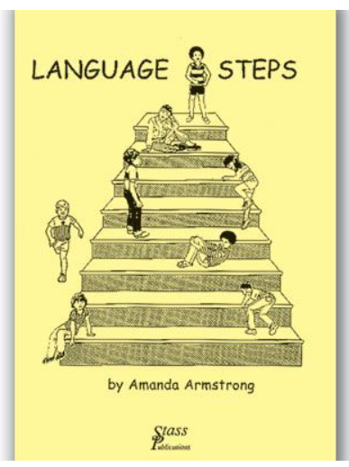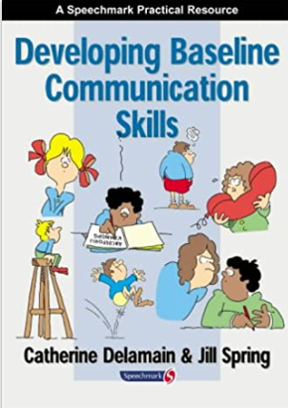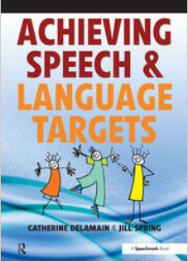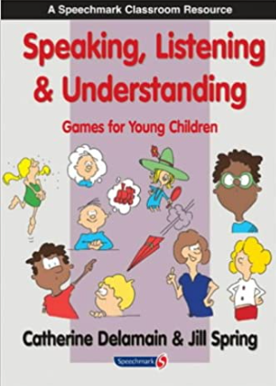

How you might use the resources in this box
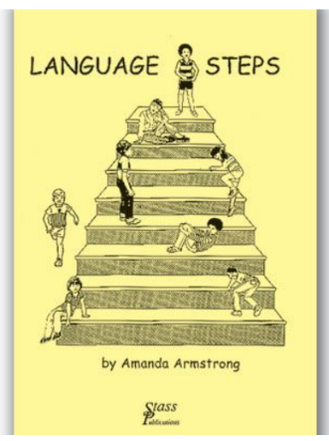

Language Steps
This is a structured framework of activities for children who are working between one- and four-word levels of understanding and talking
It is based on the idea of ‘information-carrying words’.
An ‘information-carrying word’ (ICW) is one which is required in order to fully understand the sentence. The number of ICWs will depend on the number of choices available.
For example, if I have a picture of a boy walking and a girl walking, and ask ‘show me “the boy is walking”’, there is only one ICW needed to pick the right picture (boy in this example). ‘Walking’ is not an ICW in this example because both pictures show walking, so there is no contrasting picture.
Examples:
Pictures Sentence ICWs
Boy walking Girl Walking ‘The boy is walking’ 1 ICW
Boy walking Girl Sitting ‘The boy is walking’ 1 ICW (either boy or walking is sufficient)
Boy Walking Girl Walking Boy Sitting Girl Sitting ‘The boy is walking’
2 ICW (need both ‘boy’ and ‘walking’ to choose the right picture)
The book comes with full instructions of toys and pictures needed for each stage and a comprehensive set of pictures to accompany the activities

Developing Baseline Communication Skills
This book of games and activities is ideal for working with small groups of children who need support in the baseline skills which underpin the development of good communication skills. Most of the activities can also be adapted to carry out with individual children.
It has been designed with Reception children in mind. Each skill area is presented in a developmental sequence moving from Stage 1 to Stage 4 so that you can judge the right difficulty level for your group of children. Each activity also has links back to curriculum areas such as literacy, numeracy, art and science.

You can use it to focus on
Personal & Social Development
Skills such as:
Turn-taking
Body Language
Awareness of Others
Confidence and Independence
Feelings and Emotions
Language and Literacy
Skills such as:
Understanding
Listening & Attention
Speaking
Auditory Memory
Phonological Awareness

Achieving Speech & Language Targets
This is a book of games and activities which is ideal for small groups of children who need support with their speech and language skills. Most of the activities can also be adapted to carry out with individual children.
It has been designed with Reception and Year One children in mind.
You can use it for activities which focus on aspects of understanding, talking and speech sounds. Each skill area is presented in a developmental sequence moving from so that you can judge the right difficulty level for your group of children.
Understanding Language
Skills such as:
Naming words Action words Describing words Position Words Colours
Questions Quantity Words Time words Stories
Using Language
Skills such as:
Naming words Action words Asking questions Using Grammar
Talking in Sentences
Developing Speech Sounds
Skills such as:
Discrimination Activities
Making sounds
Practising sounds

Speaking, Listening and Understanding Games for Young Children
This book of games and activities is ideal for using with groups of children who need support with their speech and language skills. Most of the activities can also be adapted to carry out with individual children.
It is particularly designed with Year 1 and Year 2 children in mind. Each skill area is presented in a developmental sequence moving from Stage 1 to Stage 4 so that you can judge the right difficulty level for your group of children. Each activity also has links back to curriculum areas such as literacy, numeracy, art and science.
You can use it to focus on
Understanding Language
Skills such as:
Following Instructions Thinking Skills
Developing Vocabulary Inference
Getting the Main Idea
Using Spoken Language
Skills such as:
Describing Predicting
Explaining Playing with Words
Narrating
`

