
Southfields Primary School Progression
Year 5

Autumn 1
 | Grammar, punctuation | Spelling | Genre skills | Handwriting
Week 1-3 | Spelling  To spell 30% of the Year 5/6 Common Exception Words.  To use a variety of prefixes and suffixes.  To spell some words with silent letters.  To distinguish between homophones and words that are easily confused.  Secure knowledge of morphology and etymology.  Use a dictionary to spell and check the meaning of words.  To use a thesaurus. | 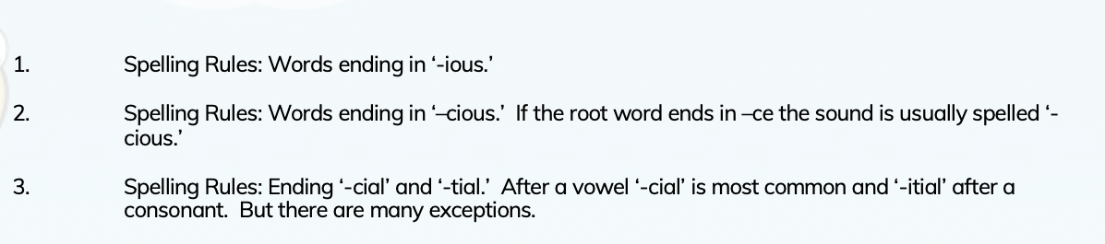 | Narrative  To re-tell familiar stories using narrative structure and dialogue from the text;  Dramatise parts of own or familiar stories and perform to class or group.  write complete stories with a sustained, logical sequence of events.  Use past tense and 3rd person consistently.  Include setting; create characters, e.g. by adapting ideas about typical story characters.  Include some dialogue.  Use phrases drawn from story language to add interest, (e.g.) she couldn’t believe her eyes.  To use speech to convey character. | Handwriting  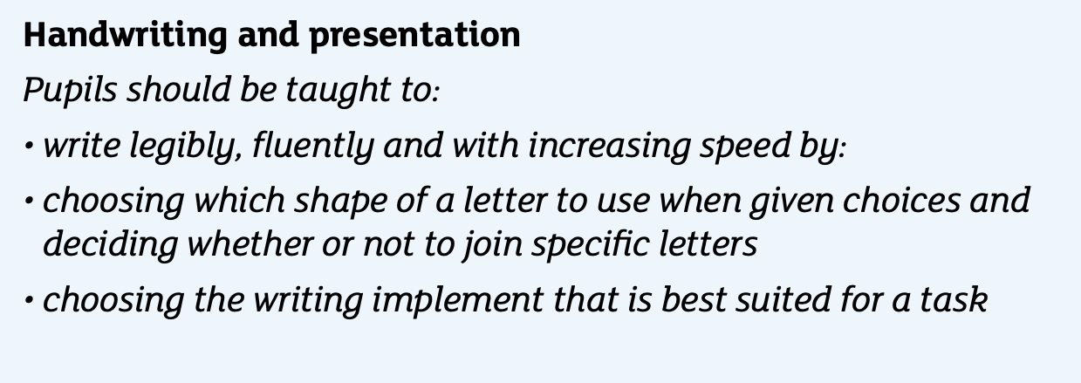  Complete Book 5.
Week 1-3 | Punctuation  To use relative clauses and commas for clauses.  To use parenthesis punctuation correctly. correctly.  To concisely use noun phrases.  Use the perfect form verbs.  To introduce bullet points.  You use the correct grammatical structure for purpose.  To use the rules of double inverted commas for dialogue.
Week 1-3 | Sentence construction  To use dialogue to convey character.  To use a variety of cohesive devices across a paragraph and a text.  To understand purpose and write carefully considering the audience.
Week 4-7 | Spelling | 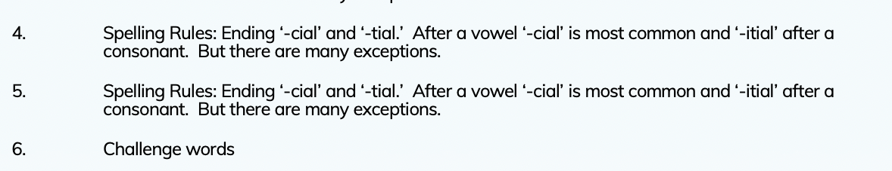 | Non chronological report  Collect information to write a report in which two or more subjects are compared, (e.g.) spiders and  beetles; solids, liquids and gases, observing that a grid rather than a spider gram is appropriate for representing the information.  Draw attention to the precision in the use of technical terminology and how many of the nouns are derived from verbs.  Teacher demonstrates the writing of a nonchronological report, including the use of organisational devices to aid conciseness such as numbered lists or headings.  Plan, compose, edit and refine short nonchronological comparative report focusing on clarity, conciseness and impersonal style.  To use correct features such as headings and sub headings.  Use formal and technical vocabulary.
Week 4-7 | Punctuation  To use relative clauses and commas for clauses.  To use brackets for parenthesis correctly.  To concisely use noun phrases.  Use the perfect form verbs.  You use the correct grammatical structure for purpose.  To use most of the rules of double inverted commas for dialogue.
Week 4-7 | Sentence construction  To use dialogue.  To use a variety of cohesive devices across a paragraph and a text.  To understand purpose.

Autumn 2
 | Grammar, punctuation | Spelling | Genre skills | Handwriting
Week 1-3 | Spelling  To spell 30% of the Year 5/6 Common Exception Words.  To use a variety of prefixes and suffixes.  To distinguish between homophones and words that are easily confused.  Secure knowledge of morphology and etymology.  Use a dictionary to spell and check the meaning of words.  To use a thesaurus. | 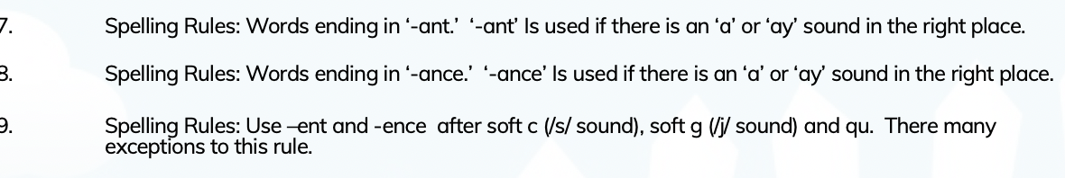 | To use similes, metaphors, personification.  To discuss meanings of words and phrases that create humour, and sound effects in poetry (nonsense poems, tongue twisters, riddles).  To write poetry that uses sound to create effects (e.g. onomatopoeia, alliteration, distinctive rhythms).  To rehearse and improve performance.  To write new and extended verses for performances based on models of ‘performance’ and oral poetry, e.g. rhythms, rhymes.  To write poems based on personal or imagined experience, linked to poems read. | LW? NF?
Week 1-3 | Punctuation  To use relative clauses and commas for clauses.  To use brackets for parenthesis correctly.  To concisely use noun phrases.  Use the perfect form verbs.  You use the correct grammatical structure for purpose.  To use most of the rules of double inverted commas for dialogue. |  |  | LW? NF?
Week 1-3 | Sentence construction  To use dialogue.  To use a variety of cohesive devices across a paragraph and a text.  To understand purpose. |  |  | LW? NF?
Week 4-7 | Spelling | 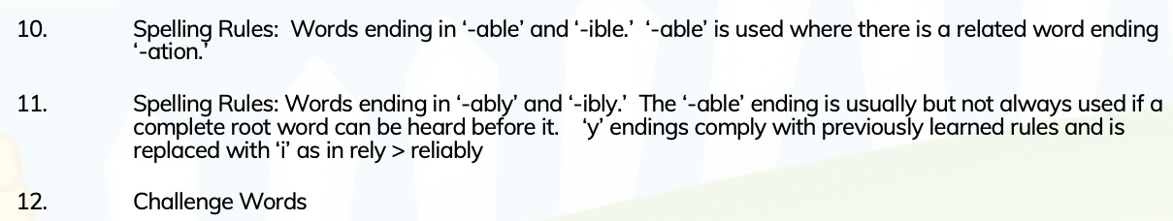 | Narrative  Narrative  To re-tell familiar stories using narrative structure and dialogue from the text;  Dramatise parts of own or familiar stories and perform to class or group.  write complete stories with a sustained, logical sequence of events.  Use past tense and 3rd person consistently.  Include setting; create characters, e.g. by adapting ideas about typical story characters.  Include some dialogue.  Use phrases drawn from story language to add interest, (e.g.) she couldn’t believe her eyes.  To use speech to convey character. | LW? NF?
Week 4-7 | Punctuation  To use relative clauses and commas for clauses.  To use brackets for parenthesis correctly.  To concisely use noun phrases.  Use the perfect form verbs.  You use the correct grammatical structure for purpose.  To use most of the rules of double inverted commas for dialogue.
Week 4-7 | Sentence construction  To use dialogue.  To use a variety of cohesive devices across a paragraph and a text.  To understand purpose. |  | Explanation  Read and analyse a range of explanatory texts.  Investigate and note features of impersonal style.  Use complex sentences.  Use of passive voice; technical vocabulary.  Use of words/phrases to make sequential, causal or logical connections.  Engage in teacher demonstration of how to research and plan a page for a reference book on one aspect of a class topic using shared note-making and writing of the page, using an impersonal style, hypothetical language (if...then, might, when the...) and causal and temporal connections (e.g. while, during, after, because, as a result, due to, only when, so) as appropriate.  In shared writing and independent work, plan, compose, edit and refine explanatory texts, using reading as a source, focusing on clarity, conciseness and impersonal style.

Spring 1
 | Grammar, punctuation | Spelling | Genre skills | Handwriting
Week 1-3 | Spelling  To spell 40% of the Year 5/6 Common Exception Words.  To use a variety of prefixes and suffixes.  To distinguish between homophones and words that are easily confused.  Secure knowledge of morphology and etymology.  Use a dictionary to spell and check the meaning of words.  To use a thesaurus. | 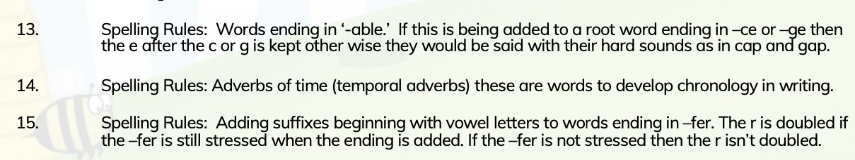 | Narrative  To re-tell familiar stories using narrative structure and dialogue from the text;  Dramatise parts of own or familiar stories and perform to class or group.  write complete stories with a sustained, logical sequence of events.  Use past tense and 3rd person consistently.  Include setting; create characters, e.g. by adapting ideas about typical story characters.  Include some dialogue.  Use phrases drawn from story language to add interest, (e.g.) she couldn’t believe her eyes.  To use speech to convey character. | Complete Book 5.
Week 1-3 | Punctuation  To use relative clauses and commas for clauses.  To use brackets for parenthesis correctly.  To concisely use noun phrases.  Use the perfect form verbs.  You use the correct grammatical structure for purpose.  To use the rules of double inverted commas for dialogue.
Week 1-3 | Sentence construction  To use dialogue to convey character.  To use a variety of cohesive devices across a paragraph and a text.  To understand purpose.
Week 4-7 | Spelling  To spell 40% of the Year 5/6 Common Exception Words.  To use a variety of prefixes and suffixes.  To distinguish between homophones and words that are easily confused.  Secure knowledge of morphology and etymology.  Use a dictionary to spell and check the meaning of words.  To use a thesaurus. |  | Instructions  In group work, give clear oral instructions to achieve the completion of a common task.  Follow oral instructions of increased complexity.  Evaluate sets of instructions (including attempting to follow some of them) for purpose, organisation and layout, clarity and usefulness.  Identify sets of instructions which are for more complex procedure or are combined with other text types (e.g. some recipes).  Compare texts in terms of audience/purpose and form (structure and language features).  To use fronted adverbials to make instructions more cohesive.
Week 4-7 | Punctuation  To use relative clauses and commas for clauses.  To use brackets for parenthesis correctly.  To concisely use noun phrases.  Use the perfect form verbs.  You use the correct grammatical structure for purpose.  To use the rules of double inverted commas for dialogue. |  | Formal letter  Understand and  use level of formality correctly, for example, writing to a friend versus writing to a Member of Parliament. That is, having an awareness of the reader.  Understand and use the correct presentation for a letter, for example, Dear and from versus Yours Faithfully or Sincerely.  Create a relevant introduction.  Create a relevant summary or conclusion.
Week 4-7 | Sentence construction  To use dialogue to convey character.  To use a variety of cohesive devices across a paragraph and a text.  To understand purpose.

Spring 2
 | Grammar, punctuation | Spelling | Genre skills | Handwriting
Week 1-3 | Spelling  To spell 50% of the Year 5/6 Common Exception Words.  To use a variety of prefixes and suffixes.  To distinguish between homophones and words that are easily confused.  Secure knowledge of morphology and etymology.  Use a dictionary to spell and check the meaning of words.  To use a thesaurus. | 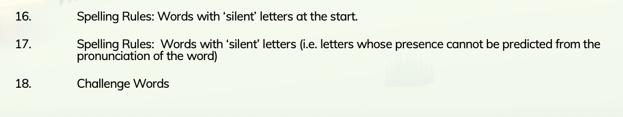 | Narrative  To re-tell familiar stories using narrative structure and dialogue from the text;  To include relevant details and sustain the listener’s interest;  Dramatise parts of own or familiar stories and perform to class or group.  write complete stories with a sustained, logical sequence of events.  Use past tense and 3rd person consistently.  Include setting; create characters, e.g. by adapting ideas about typical story characters.  Include some dialogue.  Use phrases drawn from story language to add interest, (e.g.) she couldn’t believe her eyes.  To use speech to convey character. | Handwriting  Complete Book 5.
Week 1-3 | Punctuation  To use relative clauses and commas for clauses.  To use brackets for parenthesis correctly.  To concisely use noun phrases.  Use the perfect form verbs.  You use the correct grammatical structure for purpose.  To use the rules of double inverted commas for dialogue. |  | Non chronological report  Analyse a number of report texts and note their function, form and typical language features:  Introduction indicating an overall classification of what is being described.  Use of short statement or topic sentence to introduce each new item.  Language (specific and sometimes technical) to describe and differentiate impersonal language.  Mostly present tense used.  Teacher demonstrates research and notetaking techniques using information and ICT texts on a subject and using a spidergram to organise the information.  Distinguish between generalisations and specific information and between recounts and reports.  Using content taken from another area of the curriculum.  Analyse broadcast information to identify presentation techniques and notice how the language used signals change.  Teacher demonstrates how to write nonchronological report using notes in a spidergram;  Teacher draws attention to importance of subject verb agreements with generic participants (e.g.) family is…., people are…  Write own report independently based on notes from several sources.
Week 1-3 | Sentence construction  To use dialogue to convey character.  To use a variety of cohesive devices across a paragraph and a text.  To understand purpose.
Week 4-7 | Spelling  To spell 50% of the Year 5/6 Common Exception Words.  To use a variety of prefixes and suffixes.  To distinguish between homophones and words that are easily confused.  Secure knowledge of morphology and etymology.  Use a dictionary to spell and check the meaning of words.  To use a thesaurus. |  | Explanation  Create diagrams such as flow charts to summarise or make notes of stages in a process .  Explain processes orally, using these notes, ensuring relevant details are included and accounts ended effectively.  To use technical vocabulary.
Week 4-7 | Punctuation  To use relative clauses and commas for clauses.  To use brackets for parenthesis correctly.  To concisely use noun phrases.  Use the perfect form verbs.  To introduce bullet points.  You use the correct grammatical structure for purpose.  To use the rules of double inverted commas for dialogue. |  | Poetry  To use similes, metaphors, personification.  To discuss meanings of words and phrases that create humour, and sound effects in poetry (nonsense poems, tongue twisters, riddles).  To invent calligrams and a range of shape poems, selecting appropriate words and careful presentation.  To write poetry that uses sound to create effects (e.g. onomatopoeia, alliteration, distinctive rhythms).  To rehearse and improve performance.  To write new and extended verses for performances based on models of ‘performance’ and oral poetry, e.g. rhythms, rhymes.  To write poems based on personal or imagined experience, linked to poems read.
Week 4-7 | Sentence construction  To use dialogue to convey character.  To use a variety of cohesive devices across a paragraph and a text.  To understand purpose and write carefully considering the audience.

Summer 1
 | Grammar, punctuation | Spelling | Genre skills | Handwriting
Week 1-3 | Spelling  To spell 55% of the Year 5/6 Common Exception Words.  To use a variety of prefixes and suffixes.  To distinguish between homophones and words that are easily confused.  Secure knowledge of morphology and etymology.  Use a dictionary to spell and check the meaning of words.  To use a thesaurus. | Week 1-3  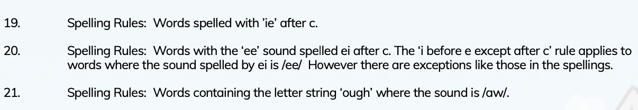  Week 4-7  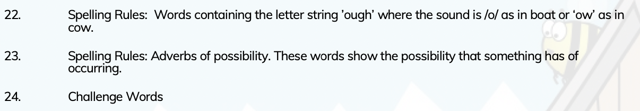 | Narrative  To re-tell familiar stories using narrative structure and dialogue from the text;  To include relevant details and sustain the listener’s interest; tell own real and imagined stories;  Dramatise parts of own or familiar stories and perform to class or group.  Use past tense and 3rd person consistently.  Include setting; create characters, e.g. by adapting ideas about typical story characters.  Include some dialogue.  Use phrases drawn from story language to add interest, (e.g.) she couldn’t believe her eyes.  To use speech to convey character. | Handwriting  Complete Book 5.
Week 1-3 | Punctuation  To use relative clauses and commas for clauses.  To use parenthesis punctuation correctly. correctly.  To concisely use noun phrases.  Use the perfect form verbs.  To introduce bullet points.  You use the correct grammatical structure for purpose.  To use the rules of double inverted commas for dialogue. |  | Explanation  Create diagrams such as flow charts to summarise or make notes of stages in a process (e.g. in science, D&T or geography), ensuring items are clearly sequenced.  Explain processes orally, using these notes, ensuring relevant details are included and accounts ended effectively.  To use technical vocabulary.
Week 1-3 | Sentence construction  To use dialogue to convey character.  To use a variety of cohesive devices across a paragraph and a text.  To understand purpose and write carefully considering the audience.
Week 4-7 | Spelling  To spell 55% of the Year 5/6 Common Exception Words.  To use a variety of prefixes and suffixes.  To spell some words with silent letters.  To distinguish between homophones and words that are easily confused.  Secure knowledge of morphology and etymology.  Use a dictionary to spell and check the meaning of words.  To use a thesaurus. |  | Instructions  Read and follow instructions.  Give clear oral instructions to members of a group.  Read and compare examples of instructional text, evaluating their effectiveness.  Analyse more complicated instructions and identify organisational devices which make them easier to follow, e.g. lists, numbered, bulleted points, diagrams with arrows, keys.  Research a particular area ( e.g. playground games) and work in small groups to prepare a set of oral instructions.  Try out with other children, giving instruction and listening and following theirs.  Evaluate effectiveness of instructions.  Write clear written instructions using correct register and devices to aid the reader.  To use fronted adverbials to support instructions.
Week 4-7 | Punctuation  To use relative clauses and commas for clauses.  To use brackets for parenthesis correctly.  To concisely use noun phrases.  Use the perfect form verbs.  To introduce bullet points.  You use the correct grammatical structure for purpose.  To use the rules of double inverted commas for dialogue. |  | Informal letter  Understand and use the layout of a letter correctly.  Use paragraphs correctly.  Understand the purpose of the letter they are writing.  Understand who will be reading the letter and if the tone should be formal or informal.  Punctuate sentences using full stops and capital letters.  Use a variation of punctuation learnt such as question marks and exclamation marks.
Week 4-7 | Sentence construction  To use dialogue to convey character.  To use a variety of cohesive devices across a paragraph and a text.  To understand purpose and write carefully considering the audience.

Summer 2
 | Grammar, punctuation | Spelling | Genre skills | Handwriting
Week 1-3 | Spelling  To spell 60% of the Year 5/6 Common Exception Words.  To use a variety of prefixes and suffixes.  To spell some words with silent letters.  To distinguish between homophones and words that are easily confused.  Secure knowledge of morphology and etymology.  Use a dictionary to spell and check the meaning of words.  To use a thesaurus. | Week 1-3  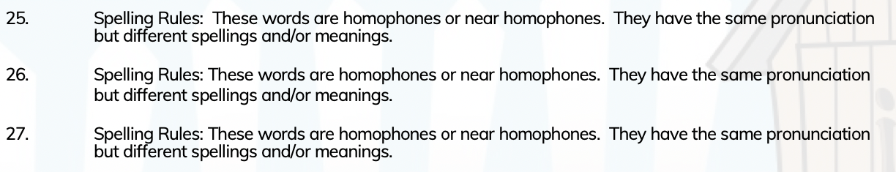  Week 4-7  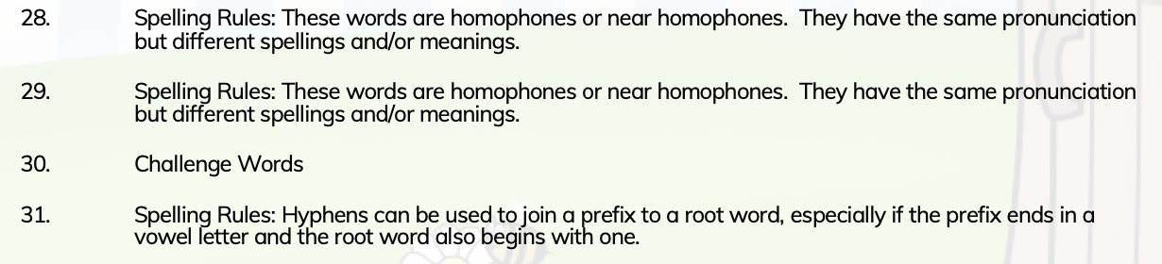 | Narrative  To re-tell familiar stories using narrative structure and dialogue from the text;  To include relevant details and sustain the listener’s interest; tell own real and imagined stories;  Explore characters’ feelings and situations using improvisation;  Dramatise parts of own or familiar stories and perform to class or group.  Imitate familiar stories by borrowing and adapting structures; write complete stories with a sustained, logical sequence of events.  Use past tense and 3rd person consistently.  Include setting; create characters, e.g. by adapting ideas about typical story characters.  Include some dialogue.  Use phrases drawn from story language to add interest, (e.g.) she couldn’t believe her eyes.  To use speech to convey character. | Handwriting  Complete Book 5.
Week 1-3 | Punctuation  To use relative clauses and commas for clauses.  To use parenthesis punctuation correctly. correctly.  To concisely use noun phrases.  Use the perfect form verbs.  To introduce bullet points.  You use the correct grammatical structure for purpose.  To use the rules of double inverted commas for dialogue. |  | Poetry  To use similes, metaphors, personification.  To discuss meanings of words and phrases that create humour, and sound effects in poetry (nonsense poems, tongue twisters, riddles).  To collect suitable words and phrases in order to write poems and short descriptions; design simple patterns with words, use repetitive phrases; write imaginative comparisons.  To invent calligrams and a range of shape poems, selecting appropriate words and careful presentation.  To write poetry that uses sound to create effects (e.g. onomatopoeia, alliteration, distinctive rhythms).  To choose and prepare poems for performance choosing appropriate expression, tone, volume and use of voices and other sounds.  To rehearse and improve performance.  To write new and extended verses for performances based on models of ‘performance’ and oral poetry, e.g. rhythms, rhymes.  To write poems based on personal or imagined experience, linked to poems read.  To understand the use of figurative language in poetry and prose;  Compare poetic phrasing with narrative/descriptive examples.  To locate use of similes.  To identify different patterns of rhyme and verse in poetry, e.g. choruses, rhyming couplets, alternate line rhymes.  To understand the following terms and identify them in poems (verse, chorus, couplet, stanza, rhythm, rhyme, alliteration).  To describe how a poet does or does not use rhyme.  To produce polished poems through revisions.
Week 1-3 | Sentence construction  To use dialogue to convey character.  To use a variety of cohesive devices across a paragraph and a text.  To understand purpose and write carefully considering the audience. |  | Persuasive brochure  Read and evaluate a wider range of simple persuasive texts, explaining and evaluating responses orally.  Begin to use words, pictures and other communication modes to persuade others when appropriate to particular writing purpose.  Through role play and drama explore particular persuasive scenarios (e.g. a parent persuading a reluctant child to go to bed.) and discuss the effectiveness of different strategies used.  Evaluate simple persuasive devices (e.g.) Say which posters in a shop or TV adverts would make them want to buy something, and why).  Create simple signs posters and adverts (involving words and/or other modes of communication) to persuade others to do, think or buy something.  To use effective vocabulary to persuade.
Week 4-7 | Spelling  To use a variety of prefixes and suffixes.  To spell some words with silent letters.  To distinguish between homophones and words that are easily confused.  Secure knowledge of morphology and etymology.  Use a dictionary to spell and check the meaning of words.  To use a thesaurus. | 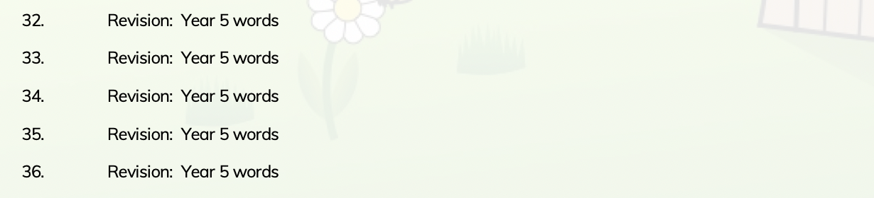
Week 4-7 | Punctuation  To use relative clauses and commas for clauses.  To use parenthesis punctuation correctly.  To concisely use noun phrases.  Use the perfect form verbs.  To introduce bullet points.  You use the correct grammatical structure for purpose.  To use the rules of double inverted commas for dialogue.
Week 4-7 | Sentence construction  To use dialogue to convey character.  To use a variety of cohesive devices across a paragraph and a text.  To understand purpose and write carefully considering the audience. |  | Balanced argument  In exploring persuasive texts, and those presenting a particular argument (see Progression in Persuasion).  Distinguish and discuss any texts that seem to be trying to present a more balanced or reasoned view, or which explore more than one possible perspective on an issue.  Experiment with the presentation of various views (own and others, biased and balanced) though discussion, debate and drama.  To use paragraphing effectively.  To link paragraphs with cohesive devices.

