
Southfields Primary School Progression
Year 4

Autumn 1
 | Grammar, punctuation | Spelling | Genre skills | Handwriting
Week 1-3 | Spelling  To spell 55% of the Year 3/4 CEW.  To start to understand knowledge of morphology and etymology. | 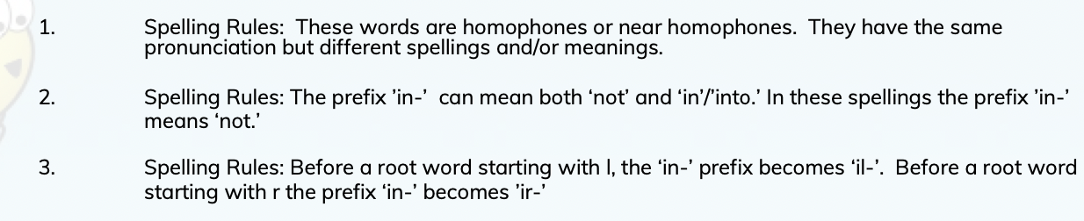 | Explanation  Read and analyse explanatory texts to identify key features.  Distinguish between explanatory texts, reports and recounts while recognising that an information book might contain examples of all these forms of text or a combination of these forms.  Orally summarise processes carried out in the classroom and on screen in flowcharts or cyclical diagrams as appropriate.  Contribute to the shared writing of an explanation where the teacher acts as scribe and models the use of paragraphs, connectives and the other key language and structural features appropriate to explanatory writing.  Purpose: to explain a process or to answer a question  Structure: introduction, followed by sequential explanation, organised into paragraphs language features.  Write consistently in present tense.  Use connectives of time and cause and effect; use of passive voice.  Presentation: use of diagrams and other illustrations, paragraphing, connectives, subheadings, numbering  After oral rehearsal, write explanatory texts independently from a flowchart or other diagrammatic plan, using the conventions modelled in shared writing. | 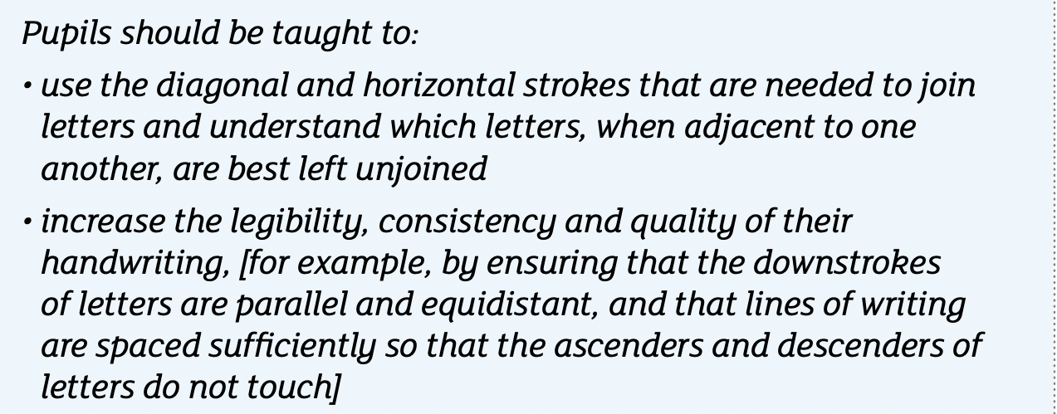  Focus on Book 4.
Week 1-3 | Punctuation  To accurately use the possessive apostrophe and apostrophes for contractions.  To know how to use double inverted commas and the following speech.  To use commas for clauses (embedded, relative, adverbials) and clarity.
Week 1-3 | Sentence construction  To effectively write for purposes.  To embed using paragraphs to organize ideas.  Write from memory sentenced dictated from the teacher.  To identify and use prepositions.  To understand what a main clause is.  To understand and use subordinate clauses.  Use verb tenses consistently.  To select vocabulary and structures for the correct formality.  ``To use a range of cohesive devices with confidence.  To understand and use some cohesive devices (adverbials, conjunctions, pronouns, synonyms) across a text and paragraph.
Week 4-7 | Punctuation  To accurately use the possessive apostrophe and apostrophes for contractions.  To know how to use double inverted commas and the following speech.  To use commas for clauses (embedded, relative, adverbials) and clarity. | 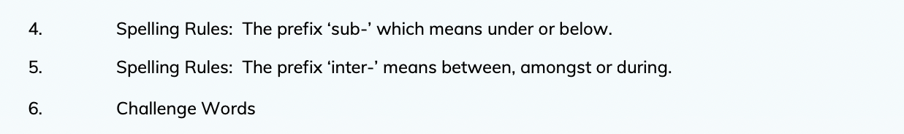 | Narrative  Develop understanding of story structure.  Recognise the stages of a story: introduction – build-up - climax or conflict – resolution.  Appreciate that chronology does not always run smoothly, (e.g.) some events are skimmed over, others are told in more depth.  Develop awareness that the author sets up dilemmas in the story and devises a solution.  Understand that the author or director creates characters to provoke a response in the reader, (e.g.) sympathy or dislike.  Discuss whether the narrator has a distinctive voice in the story.  Identify the use of figurative and expressive language to build a fuller picture of a character.  Authors can create entire imaginary worlds; look for evidence of small details that are used to evoke time, place and mood.
Week 4-7 | Sentence construction  To effectively write for purposes.  To embed using paragraphs to organize ideas.  Write from memory sentenced dictated from the teacher.  To identify and use prepositions.  To understand what a main clause is.  To understand and use subordinate clauses.  Use verb tenses consistently.  To select vocabulary and structures for the correct formality.  ``To use a range of cohesive devices with confidence.  To understand and use some cohesive devices (adverbials, conjunctions, pronouns, synonyms) across a text and paragraph.
Week 4-7 | Spelling  To further understand knowledge of morphology and etymology.  To spell 60% of the Year 3/4 CEW.  To start to understand knowledge of morphology and etymology.

Autumn 2
 | Grammar, punctuation | Spelling | Genre skills | Handwriting
Week 1-3 | Spelling  To spell 60% of the Year 3/4 CEW.  To use the first three letters of a word to locate it in a dictionary.  To spell common homophones correctly.  To further understand knowledge of morphology and etymology. | 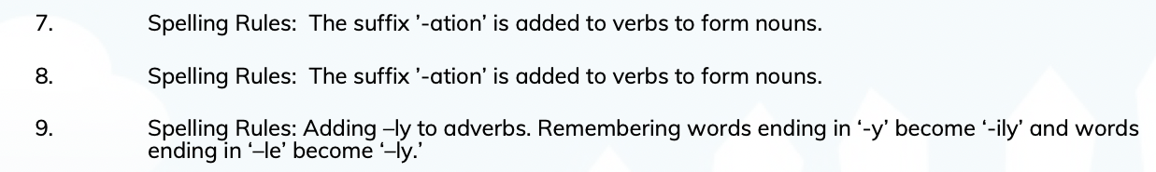 | Poetry  To understand the following terms and identify them in poems: verse, chorus, couplet, stanza, rhythm, rhyme and alliteration.  To describe how a poet does or does not use rhyme.  To produce polished poems through revisions.  To analyse and compare poetic style, use of forms and the themes of significant poets.  To respond to shades of meaning; to explain and justify personal tastes.  To consider the impacts of full rhymes, half rhymes, internal rhymes and other sound patterns.  To investigate and collect different examples of word play.  To convey feelings, reflections or moods in a poem through the careful choice of words and phrases.  To write metaphors from original ideas or from similes.  To understand terms that describe different types of poems, e.g. ballad, sonnet, rap, elegy, narrative poem and identify typical features.  To discuss how linked poems relate to one another by themes, format and repetition, e.g. cycle of poems about the seasons.  To describe and evaluate the style of an individual poet.  To comment critically on the overall impact of a poem, showing how language and themes have been developed.  To write their own poems experimenting with active verbs and personification. | Focus on Book 4.
Week 1-3 | Punctuation  To accurately use the possessive apostrophe and apostrophes for contractions.  To know how to use double inverted commas and the following speech.  To use commas for clauses (adverbials) and clarity.
Week 1-3 | Sentence construction  To effectively write for purposes.  To embed using paragraphs to organize ideas.  Write from memory sentenced dictated from the teacher.  To identify and use prepositions.  To understand what a main clause is.  To understand and use subordinate clauses.  Use verb tenses consistently.  To select vocabulary and structures for the correct formality.  `To use a range of cohesive devices with confidence.  To understand and use some cohesive devices (adverbials, conjunctions, pronouns, synonyms) across a paragraph. |  | Letter writing  Understand and use level of formality correctly, for example, writing to a friend versus writing to a Member of Parliament.  Having an awareness of the reader.  Understand and use the correct presentation for a letter, for example, Dear and from versus Yours Faithfully or Sincerely.  Create a relevant introduction.  Create a relevant summary or conclusion.
Week 4-7 | Spelling  To spell 60% of the Year 3/4 CEW.  To use the first three letters of a word to locate it in a dictionary.  To spell common homophones correctly.  To further understand knowledge of morphology and etymology. | 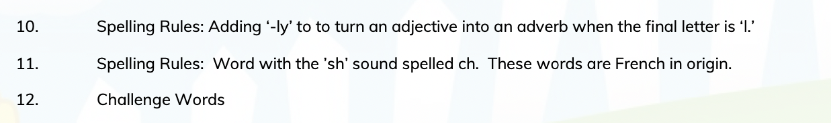
Week 4-7 | Punctuation  To accurately use the possessive apostrophe and apostrophes for contractions.  To know how to use double inverted commas and the following speech.  To use commas for clauses ( adverbials) and clarity. |  | Narrative  Develop understanding of story structure.  Recognise the stages of a story: introduction – build-up - climax or conflict – resolution.  Appreciate that chronology does not always run smoothly, (e.g.) some events are skimmed over, others are told in more depth.  Develop awareness that the author sets up dilemmas in the story and devises a solution.  Understand that the author or director creates characters to provoke a response in the reader, (e.g.) sympathy or dislike.  Discuss whether the narrator has a distinctive voice in the story.  Identify the use of figurative and expressive language to build a fuller picture of a character.  Explore the way that key characters respond to a dilemma and make deductions about their motives and feelings.  Authors can create entire imaginary worlds; look for evidence of small details that are used to evoke time, place and mood.  Explore evidence of the way that characters behave in different settings.
Week 4-7 | Sentence construction  To effectively write for purposes.  To embed using paragraphs to organize ideas.  Write from memory sentenced dictated from the teacher.  To identify and use prepositions.  To understand what a main clause is.  To understand and use subordinate clauses.  Use verb tenses consistently.  To select vocabulary and structures for the correct formality.  `To use a range of cohesive devices with confidence.  To understand and use some cohesive devices (adverbials, conjunctions, pronouns, synonyms) across a paragraph.

Spring 1
 | Grammar, punctuation | Spelling | Genre skills |  | Handwriting
Week 1-3 | Spelling  To spell 65% of the Year 3/4 CEW.  To use the first three letters of a word to locate it in a dictionary.  To spell common homophones correctly.  To further understand knowledge of morphology and etymology. | 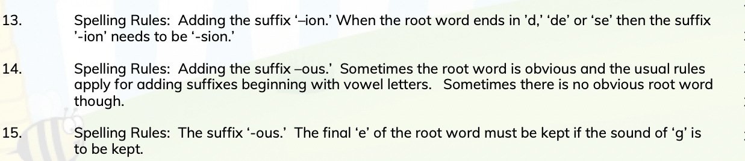  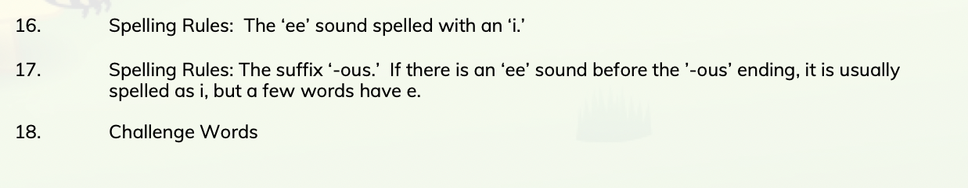 | Poetry  To understand the following terms and identify them in poems: verse, chorus, couplet, stanza, rhythm, rhyme and alliteration.  To describe how a poet does or does not use rhyme.  To produce polished poems through revisions.  To analyse and compare poetic style, use of forms and the themes of significant poets.  To respond to shades of meaning; to explain and justify personal tastes.  To consider the impacts of full rhymes, half rhymes, internal rhymes and other sound patterns.  To investigate and collect different examples of word play.  To convey feelings, reflections or moods in a poem through the careful choice of words and phrases.  To write metaphors from original ideas or from similes.  To understand terms that describe different types of poems, e.g. ballad, sonnet, rap, elegy, narrative poem and identify typical features.  To discuss how linked poems relate to one another by themes, format and repetition, e.g. cycle of poems about the seasons.  To describe and evaluate the style of an individual poet.  To comment critically on the overall impact of a poem, showing how language and themes have been developed.  To write their own poems experimenting with active verbs and personification. |  | Focus on Book 4.
Week 1-3 | Punctuation  To accurately use the possessive apostrophe and apostrophes for contractions.  To know how to use double inverted commas and the following speech.  To use commas for clauses ( adverbials) and clarity.
Week 1-3 | Sentence construction  To effectively write for purposes.  To embed using paragraphs to organize ideas.  Write from memory sentenced dictated from the teacher.  To identify and use prepositions.  To understand what a main clause is.  To understand and use subordinate clauses.  Use verb tenses consistently.  To select vocabulary and structures for the correct formality.  `To use a range of cohesive devices with confidence.  To understand and use some cohesive devices (adverbials, conjunctions, pronouns, synonyms) across a text and paragraph.
Week 4-7 | Spelling  To spell 65% of the Year 3/4 CEW.  To use the first three letters of a word to locate it in a dictionary.  To spell common homophones correctly.  To further understand knowledge of morphology and etymology. |  | Fact file report  Pose and orally rehearse questions ahead of writing and record these in writing, before reading.  Recognise that non-fiction books on similar themes can give different information and present similar information in different ways.  Use contents pages and alphabetically ordered texts (e.g.) dictionaries, encyclopaedias, indexes, directories, registers.  Locate definitions/ explanations in dictionaries and glossaries.  Write simple information texts incorporating labelled pictures and diagrams, charts, lists as appropriate.  Draw on knowledge and experience of texts in deciding and planning what and how to write.  Maintain consistency in non- narrative, including purpose and tense.  Create an alphabetically ordered dictionary or glossary of special interest words.  Design and create a simple ICT text.  Scan texts to find specific sections (e.g. key words or phrases, subheadings) and skim-read title, contents page, illustration, chapter headings and sub-headings to speculate what a book might be about and evaluate its usefulness for the research in hand. Scan a website to find specific sections e.g. key words or phrases, subheadings.  Appraise icons, drop down menus and other hyperlinks to speculate what it might lead to and evaluate its usefulness for the research in hand.  Close read text to gain information, finding the meaning of unknown words by deducing from text, asking someone, or referring to a dictionary or encyclopaedia.  Make simple notes from non-fiction texts, e.g. key words and phrases, page references, headings, to use in subsequent writing.
Week 4-7 | Punctuation  To accurately use the possessive apostrophe and apostrophes for contractions.  To know how to use double inverted commas and the following speech.  To use commas for clauses ( adverbials) and clarity.
Week 4-7 | Sentence construction  To effectively write for purposes.  To embed using paragraphs to organize ideas.  Write from memory sentenced dictated from the teacher.  To identify and use prepositions.  To understand what a main clause is.  To understand and use subordinate clauses.  Use verb tenses consistently.  To select vocabulary and structures for the correct formality.  `To use a range of cohesive devices with confidence.  To understand and use some cohesive devices (adverbials, conjunctions, pronouns, synonyms) across a text and paragraph.

Spring 2
 | Grammar, punctuation | Spelling | Genre skills | Handwriting
Week 1-3 | Spelling  To spell 70% of the Year 3/4 CEW.  To use the first three letters of a word to locate it in a dictionary.  To spell common homophones correctly.  To further understand knowledge of morphology and etymology. | 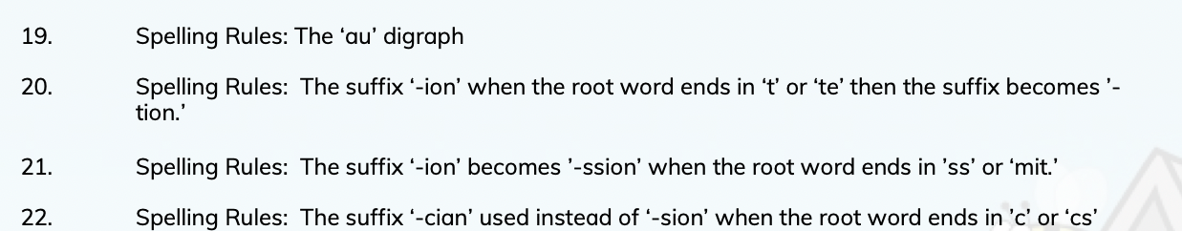  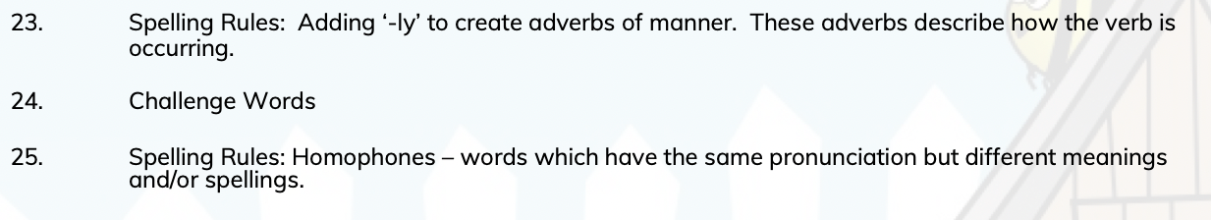 | Newspaper recount  After a practical activity or undertaking some research in books or the web, take part in a discussion in another curriculum subject, generalising from repeated occurrences or observations.  Distinguish between a description of a single member of a group and the group in general e.g. a particular dog and dogs in general. Read texts containing information in a simple report format, e.g. There are two sorts of x...; They live in x...; the As have x..., but the B’s etc.  Assemble information on another subject and use the text as a template for writing a report on it, using appropriate language to present and categorise ideas.  Write simple first person recounts linked to topics of interest/study or to personal experience, using the language of texts read as models for own writing.  Maintain a consistency in tense and in 3rd person. | Focus on Book 4.  Maintain fluency when writing at speed.
Week 1-3 | Punctuation  To accurately use the possessive apostrophe and apostrophes for contractions.  To know how to use double inverted commas and the following speech.  To use commas for clauses ( adverbials) and clarity. |  | Narrative  Develop understanding of story structure.  Recognise the stages of a story: introduction – build-up - climax or conflict – resolution.  Appreciate that chronology does not always run smoothly, (e.g.) some events are skimmed over, others are told in more depth.  Develop awareness that the author sets up dilemmas in the story and devises a solution.  Understand that the author or director creates characters to provoke a response in the reader, (e.g.) sympathy or dislike.  Discuss whether the narrator has a distinctive voice in the story.  Identify the use of figurative and expressive language to build a fuller picture of a character.  Explore the way that key characters respond to a dilemma and make deductions about their motives and feelings.  Discuss whether a character’s behaviour was predictable or unexpected.  Explore the relationship between what characters say and what they do – do they always reveal what they are thinking?  Authors can create entire imaginary worlds; look for evidence of small details that are used to evoke time, place and mood.  Explore evidence of the way that characters behave in different settings.
Week 1-3 | Sentence construction  To effectively write for purposes.  To embed using paragraphs to organize ideas.  Write from memory sentenced dictated from the teacher.  To identify and use prepositions.  To understand what a main clause is.  To understand and use subordinate clauses.  Use verb tenses consistently.  To select vocabulary and structures for the correct formality.  `To use a range of cohesive devices with confidence.  To understand and use some cohesive devices (adverbials, conjunctions, pronouns, synonyms) across a text and paragraph.
Week 4-7 | Spelling  To spell 80% of the Year 3/4 CEW.  To use the first three letters of a word to locate it in a dictionary.  To spell common homophones correctly.  To further understand knowledge of morphology and etymology.
Week 4-7 | Punctuation  To accurately use the possessive apostrophe and apostrophes for contractions.  To know how to use double inverted commas and the following speech.  To use commas for clauses ( adverbials) and clarity.
Week 4-7 | Sentence construction  To effectively write for purposes.  To embed using paragraphs to organize ideas.  Write from memory sentenced dictated from the teacher.  To identify and use prepositions.  To understand what a main clause is.  To understand and use subordinate clauses.  Use verb tenses consistently.  To select vocabulary and structures for the correct formality.  `To use a range of cohesive devices with confidence.  To understand and use some cohesive devices (adverbials, conjunctions, pronouns, synonyms) across a text and paragraph.

Summer 1
 | Grammar, punctuation | Spelling | Genre skills | Handwriting
Week 1-3 | Spelling  To spell 75% of the Year 3/4 CEW.  To use the first three letters of a word to locate it in a dictionary.  To further understand knowledge of morphology and etymology.  To spell common homophones correctly. | Week 1-3  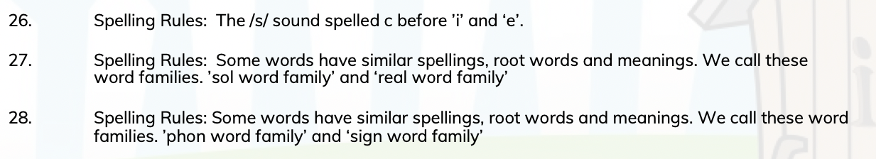  Week 4-7  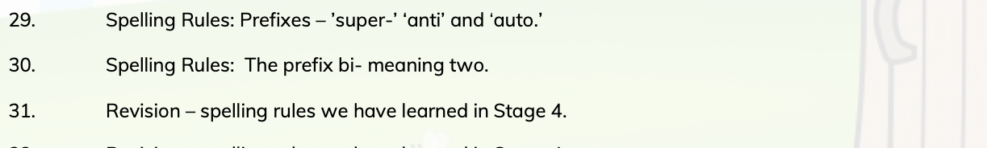 | Playscript  Play scripts  - Understand and use layout correctly, for example, colons, new line for each new speaker etc.  Understand and use stage directions.  Understand and use ‘scenes’ and/or ‘acts.’  Understand no inverted commas are used, even though the characters are speaking.  Use introduction at the start of each scene to give a brief description of where the scene is set.  Use correct ARE punctuation (KS1/year 4 level). | Focus on Book 4.  Maintain fluency when writing at speed.
Week 1-3 | Punctuation  To accurately use the possessive apostrophe and apostrophes for contractions.  To know how to use double inverted commas and the following speech.  To use commas for clauses (relative, adverbials) and clarity.
Week 1-3 | Sentence construction  To effectively write for purposes.  To embed using paragraphs to organize ideas.  Write from memory sentenced dictated from the teacher.  To identify and use prepositions.  To understand what a main clause is.  To understand and use subordinate clauses.  Use verb tenses consistently.  To select vocabulary and structures for the correct formality.  ``To use a range of cohesive devices with confidence.  To understand and use some cohesive devices (adverbials, conjunctions, pronouns, synonyms) across a text and paragraph.
Week 4-7 | Spelling  To spell 75% of the Year 3/4 CEW.  To use the first three letters of a word to locate it in a dictionary.  To spell common homophones correctly.  To further understand knowledge of morphology and etymology. |  | Narrative  Develop understanding of story structure.  Recognise the stages of a story: introduction – build-up - climax or conflict – resolution.  Appreciate that chronology does not always run smoothly, (e.g.) some events are skimmed over, others are told in more depth.  Develop awareness that the author sets up dilemmas in the story and devises a solution.  Discuss whether the narrator has a distinctive voice in the story.  Identify the use of figurative and expressive language to build a fuller picture of a character.  Explore the way that key characters respond to a dilemma and make deductions about their motives and feelings.  Discuss whether a character’s behaviour was predictable or unexpected.  Explore the relationship between what characters say and what they do – do they always reveal what they are thinking?  Authors can create entire imaginary worlds; look for evidence of small details that are used to evoke time, place and mood.  Explore evidence of the way that characters behave in different settings.
Week 4-7 | Punctuation  To accurately use the possessive apostrophe and apostrophes for contractions.  To know how to use double inverted commas and the following speech.  To use commas for clauses (relative, adverbials) and clarity. |  | Explanation  Read and analyse explanatory texts to identify key features.  Distinguish between explanatory texts, reports and recounts while recognising that an information book might contain examples of all these forms of text or a combination of these forms.  Orally summarise processes carried out in the classroom and on screen in flowcharts or cyclical diagrams as appropriate.  Use paragraphs, connectives and the other key language and structural features appropriate to explanatory writing.  Purpose: to explain a process or to answer a question.  Structure: introduction, followed by sequential explanation, organised into paragraphs language features.  Write consistently in present tense.  Use connectives of time and cause and effect; use of passive voice.  Use diagrams and other illustrations, paragraphing, connectives, subheadings, numbering  After oral rehearsal, write explanatory texts independently from a flowchart or other diagrammatic plan, using the conventions modelled in shared writing.
Week 4-7 | Sentence construction  To effectively write for purposes.  To embed using paragraphs to organize ideas.  Write from memory sentenced dictated from the teacher.  To identify and use prepositions.  To understand what a main clause is.  To understand and use subordinate clauses.  Use verb tenses consistently.  To select vocabulary and structures for the correct formality.  ``To use a range of cohesive devices with confidence.  To understand and use some cohesive devices (adverbials, conjunctions, pronouns, synonyms) across a text and paragraph.

Summer 2
 | Grammar, punctuation | Spelling | Genre skills | Handwriting
Week 1-3 | Spelling  To spell 80% of the Year 3/4 CEW.  To use the first three letters of a word to locate it in a dictionary.  To spell common homophones correctly.  To further understand knowledge of morphology and etymology. | Week 1-3  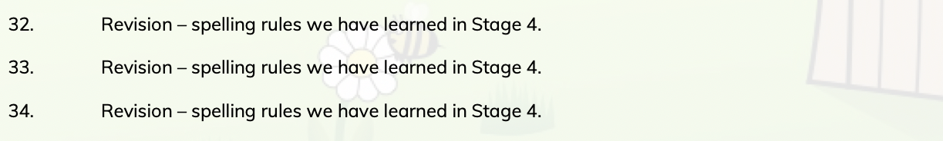  Week 4-7 | Narrative  Develop understanding of story structure.  Recognise the stages of a story: introduction – build-up - climax or conflict – resolution  Appreciate that chronology does not always run smoothly, (e.g.) some events are skimmed over, others are told in more depth.  Develop awareness that the author sets up dilemmas in the story and devises a solution.  Make judgements about the success of the narrative, (e.g.) do you agree with the way that the problem was solved?  Understand that the author or director creates characters to provoke a response in the reader, (e.g.) sympathy or dislike.  Discuss whether the narrator has a distinctive voice in the story.  Identify the use of figurative and expressive language to build a fuller picture of a character.  Explore the way that key characters respond to a dilemma and make deductions about their motives and feelings.  Discuss whether a character’s behaviour was predictable or unexpected.  Explore the relationship between what characters say and what they do – do they always reveal what they are thinking?  Authors can create entire imaginary worlds; look for evidence of small details that are used to evoke time, place and mood.  Explore evidence of the way that characters behave in different settings. | Focus on Book 4.  Maintain fluency when writing at speed.  write legibly, fluently and with increasing speed by:  choosing which shape of a letter to use when given choices and deciding whether or not to join specific letters  choosing the writing implement that is best suited for a task
Week 1-3 | Punctuation  To accurately use the possessive apostrophe and apostrophes for contractions.  To know how to use double inverted commas and the following speech.  To use commas for clauses (embedded, relative, adverbials) and clarity. |  | Poetry  To understand the following terms and identify them in poems: verse, chorus, couplet, stanza, rhythm, rhyme and alliteration.  To describe how a poet does or does not use rhyme.  To produce polished poems through revisions.  To analyse and compare poetic style, use of forms and the themes of significant poets.  To respond to shades of meaning; to explain and justify personal tastes.  To consider the impacts of full rhymes, half rhymes, internal rhymes and other sound patterns.  To investigate and collect different examples of word play.  To convey feelings, reflections or moods in a poem through the careful choice of words and phrases.  To write metaphors from original ideas or from similes.  To understand terms that describe different types of poems, e.g. ballad, sonnet, rap, elegy, narrative poem and identify typical features.  To discuss how linked poems relate to one another by themes, format and repetition, e.g. cycle of poems about the seasons.  To describe and evaluate the style of an individual poet.  To comment critically on the overall impact of a poem, showing how language and themes have been developed.  To write their own poems experimenting with active verbs and personification.
Week 1-3 | Sentence construction  To effectively write for purposes.  To embed using paragraphs to organize ideas.  Write from memory sentenced dictated from the teacher.  To identify and use prepositions.  To understand what a main clause is.  To understand and use subordinate clauses.  Use verb tenses consistently.  To select vocabulary and structures for the correct formality.  ``To use a range of cohesive devices with confidence.  To understand and use some cohesive devices (adverbials, conjunctions, pronouns, synonyms) across a text and paragraph. |  | Persuasion  Read and analyse a range of persuasive texts to identify key features (e.g. letters to newspapers, discussions of issues in books, such as animal welfare or  environmental issues).  Distinguish between texts that try to persuade and those that simply inform whilst recognising that some texts might contain examples of each of these.  Analyse how a particular view can most convincingly be presented, e.g. ordering points to link them together so that one follows from another; how statistics, graphs, images, visual aids, etc. can be used to support or reinforce arguments from examples of persuasive writing, investigate how style and vocabulary are used to convince the reader.  Evaluate advertisements for their impact, appeal and honesty, focusing in particular on how information about the product is presented: exaggerated claims, tactics for grabbing attention, linguistic devices such as puns, jingles, alliteration, invented words, both orally and in and writing to assemble and sequence points in order to plan the presentation of a point of view, e.g. on hunting, school rules using more formal language appropriately.  Use writing frames if necessary to back up points of view with illustrations and examples.  To present a point of view both orally and in writing,( e.g. in the form of a letter, a report or presentation) linking points persuasively and selecting style and vocabulary appropriate to the listener/reader; begin to explore how ICT other use of multimodality might support this. (e.g. showing pictures.)  Design an advertisement, such as a poster or radio jingle, on paper or screen, e.g. for a school fête or an imaginary product, making use of linguistic and other features learnt from reading examples  Explore the use of connectives, e.g. adverbs, adverbial phrases, conjunctions, to structure a persuasive argument, e.g. ‘if…, then’; ‘on the other hand…’; ‘finally’;  ‘so’
Week 4-7 | Spelling  To spell 80% of the Year 3/4 CEW.  To use the first three letters of a word to locate it in a dictionary.  To spell common homophones correctly.
Week 4-7 | Punctuation  To accurately use the possessive apostrophe and apostrophes for contractions.  To know how to use double inverted commas and the following speech.  To use commas for clauses (embedded, relative, adverbials) and clarity.
Week 4-7 | Sentence construction  To effectively write for purposes.  To embed using paragraphs to organize ideas.  Write from memory sentenced dictated from the teacher.  To identify and use prepositions.  To understand what a main clause is.  To understand and use subordinate clauses.  Use verb tenses consistently.  To select vocabulary and structures for the correct formality.  ``To use a range of cohesive devices with confidence.  To understand and use some cohesive devices (adverbials, conjunctions, pronouns, synonyms) across a text and paragraph.

