
Southfields Primary School Progression
Year 3

Autumn 1
 | Grammar, punctuation | Spelling | Genre skills | Handwriting
Week 1-3 | Spelling  To spell 75% of the Year 2 CEW.  To spell further homophones.  To use the first three letters of a word to apply it to a dictionary. | 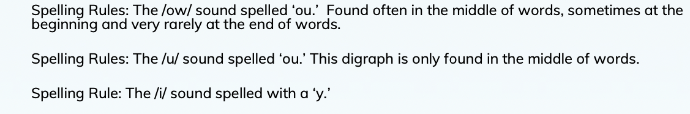 | Narrative  Describe settings and characters.  Write complete stories with a full sequence of events in narrative order Including a dilemma or conflict and resolution.  Write an opening paragraph and further paragraphs for each stage of the story.  Use either first or third person consistently.  Use conventions for written dialogue use dialogue to create atmosphere...  Consolidate understanding of sequential story structure: identify common, formal elements in story openings and endings and typical features of particular types of story.  Notice common themes,  Note the use of language to set scenes, build tension, create suspense.  Settings are used to create atmosphere. | 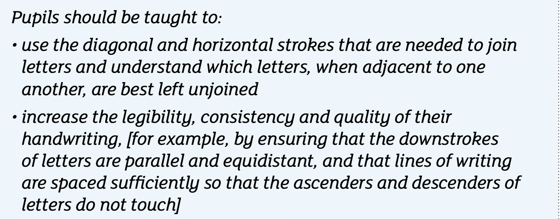  Focus on the formation of a to a to k.
Week 1-3 | Punctuation  Use the possessive apostrophe and apostrophes for contractions.  To know how to use double inverted commas and the following speech.
Week 1-3 | Sentence construction  To write for purposes.  To use paragraphs to organize ideas.  Write from memory sentenced dictated from the teacher.  To understand what a main clause is.  Use verb tenses consistently.
Week 4-7 | Spelling  To spell 20% of the Year 3/4 CEW. | 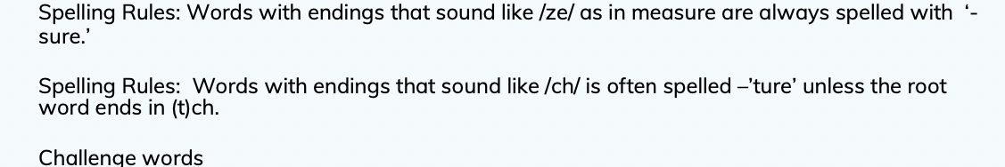 | Letter  Understand and use the layout of a letter correctly.  Use paragraphs correctly.  Understand the purpose of the letter they are writing.  Understand who will be reading the letter.  Use persuasive words and phrases for purpose.  Punctuate sentences using full stops and capital letters.  Use a variation of punctuation learnt such as question marks and exclamation marks.
Week 4-7 | Punctuation  Use the possessive apostrophe and apostrophes for contractions.  To know how to use double inverted commas and the following speech. |  | Poetry  To use similes, metaphors,  personification.  To collect suitable words and phrases in order to write poems and short descriptions;  To write poetry that uses sound to create effects (e.g. onomatopoeia, alliteration).  To choose and prepare poems for performance choosing appropriate expression, tone, volume and use of voices and other sounds.  To rehearse and improve performance.  To locate use of similes.
Week 4-7 | Sentence construction  To write for purposes.  To use paragraphs to organize ideas.  Write from memory sentenced dictated from the teacher.  To understand what a main clause is.  Use verb tenses consistently.

Autumn 2
 | Grammar, punctuation | Spelling | Genre skills | Handwriting
Week 1-3 | Spelling  To spell 30% of the Year 3/4 CEW. | 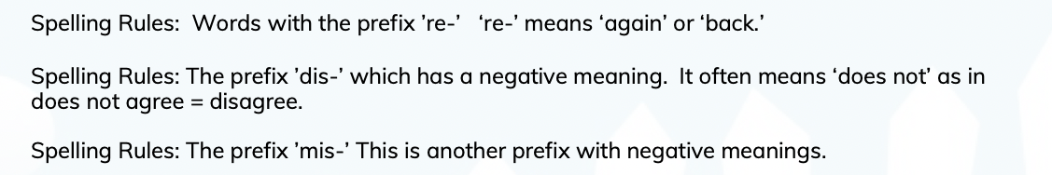 | Poetry  To use similes, metaphors,  personification.  To collect suitable words and phrases in order to write poems and short descriptions;  To write poetry that uses sound to create effects (e.g. onomatopoeia, alliteration, distinctive rhythms).  To choose and prepare poems for performance choosing appropriate expression, tone, volume and use of voices and other sounds.  To rehearse and improve performance.  To locate use of similes. | Focus on the formation of a to a to p
Week 1-3 | Punctuation  Use the possessive apostrophe and apostrophes for contractions.  To know how to use double inverted commas and the following speech. |  |  | Focus on the formation of a to a to p
Week 1-3 | Sentence construction  To write for purposes.  To use paragraphs to organize ideas.  Write from memory sentenced dictated from the teacher.  To understand what a main clause is.  Use verb tenses consistently. |  |  | Focus on the formation of a to a to p
Week 4-7 | Spelling  To spell 35% of the Year 3/4 CEW. | 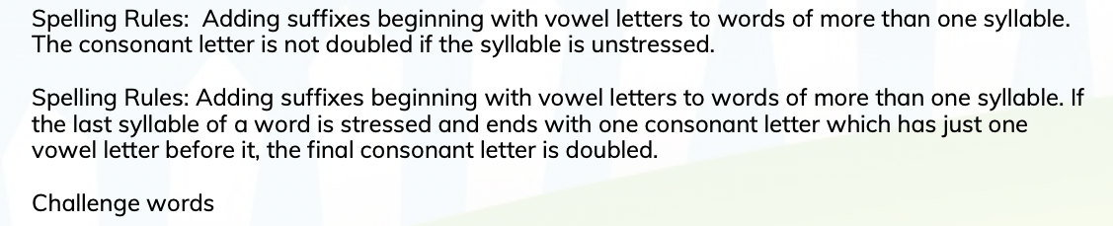 | Letter  Understand and use the layout of a letter correctly.  Use paragraphs correctly.  Understand the purpose of the letter they are writing.  Punctuate sentences using full stops and capital letters.  Use a variation of punctuation learnt such as question marks and exclamation marks. | Focus on the formation of a to a to p
Week 4-7 | Punctuation  Use the possessive apostrophe and apostrophes for contractions.  To know how to use double inverted commas and the following speech.
Week 4-7 | Sentence construction  To write for purposes.  To use paragraphs to organize ideas.  Write from memory sentenced dictated from the teacher.  To understand what a main clause is.  Use verb tenses consistently.

Spring 1
 | Grammar, punctuation | Spelling | Genre skills | Handwriting
Week 1-3 | Spelling  To spell 40% of the Year 3/4 CEW. | 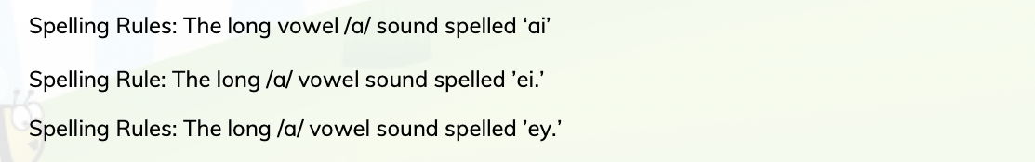 | Poetry  To use similes, metaphors, personification.  To discuss meanings of words and phrases that create humour, and sound effects in poetry (nonsense poems, tongue twisters, riddles).  To collect suitable words and phrases in order to write poems and short descriptions;  To write poetry that uses sound to create effects (e.g. onomatopoeia, alliteration, distinctive rhythms).  To choose and prepare poems for performance choosing appropriate expression, tone, volume and use of voices and other sounds.  To rehearse and improve performance.  To locate use of similes.  To identify different patterns of rhyme and verse in poetry, e.g. choruses, rhyming couplets, alternate line rhymes.  To understand the following terms and identify them in poems (verse, chorus, couplet, stanza, rhythm, rhyme, alliteration). | Focus on the formation of p to z.
Week 1-3 | Punctuation  Punctuation  Use the possessive apostrophe and apostrophes for contractions.  To know how to use double inverted commas and the following speech.
Week 1-3 | Sentence construction  To write for purposes.  To use paragraphs to organize ideas.  Write from memory sentenced dictated from the teacher.  To understand what a main clause is.  To understand and use subordinate clauses.  Use verb tenses consistently.
Week 4-7 | Spelling  To spell 45% of the Year 3/4 CEW. | 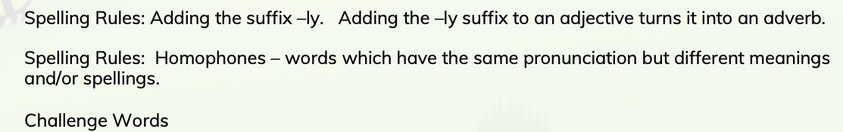 | Non chronological report  Pose and orally rehearse questions ahead of writing and record these in writing, before reading.  Recognise that non-fiction books on similar themes can give different information and present similar information in different ways.  Write simple information texts incorporating labelled pictures and diagrams, charts, lists as appropriate.  Draw on knowledge and experience of texts in deciding and planning what and how to write.  Use organisational techniques such as sub headings, bullet points, paragraphing.
Week 4-7 | Punctuation  Punctuation  Use the possessive apostrophe and apostrophes for contractions.  To know how to use double inverted commas and the following speech.
Week 4-7 | Sentence construction  To write for purposes.  To use paragraphs to organize ideas.  Write from memory sentenced dictated from the teacher.  To understand what a main clause is.  To understand and use subordinate clauses.  Use verb tenses consistently. |  | Playscript  - Understand and use layout correctly, for example, colons, new line for each new speaker etc.  - Understand and use stage directions.  Understand and use ‘scenes’ and/or ‘acts.’  Understand no inverted commas are used, even though the characters are speaking.  Use introduction at the start of each scene to give a brief description of where the scene is set.  - Use correct ARE punctuation (KS1/year 3 level).

Spring 2
 | Grammar, punctuation | Spelling | Genre skills | Handwriting
Week 1-3 | Spelling  To spell 50% of the Year 3/4 CEW. | 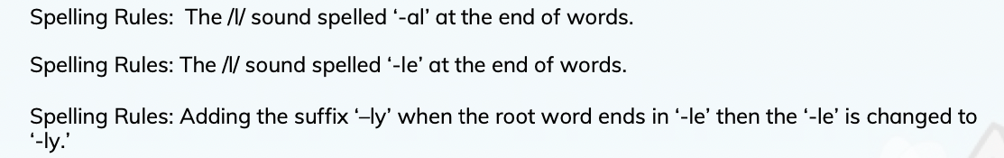 | recount | Focus on the formation of p to z.
Week 1-3 | Punctuation  Punctuation  Use the possessive apostrophe and apostrophes for contractions.  To know how to use double inverted commas and the following speech. |  | Traditional tale Narrative  Describe settings and characters.  Write complete stories with a full sequence of events in narrative order Including a dilemma or conflict and resolution.  Write an opening paragraph and further paragraphs for each stage of the story.  Use either first or third person consistently.  Use conventions for written dialogue and use dialogue to create atmosphere.  Consolidate understanding of sequential story structure: identify common, formal elements in story openings and endings and typical features of particular types of story.  Note the use of language to set scenes, build tension, create suspense.  Notice the difference between first and third person accounts; Identify examples of a character telling the story in the first person;  Settings are used to create atmosphere.
Week 1-3 | Sentence construction  To write for purposes.  To use paragraphs to organize ideas.  Write from memory sentenced dictated from the teacher.  To identify and use prepositions.  To understand what a main clause is.  To understand and use subordinate clauses.  Use verb tenses consistently. |  | Letter  Understand and use the layout of a letter correctly.  Use paragraphs correctly.  Understand the purpose of the letter they are writing.  Understand who will be reading the letter and if the tone should be formal or informal.  Punctuate sentences using full stops and capital letters.  Use a variation of punctuation learnt such as question marks and exclamation marks.
Week 4-7 | Spelling  To spell 50% of the Year 3/4 CEW. | 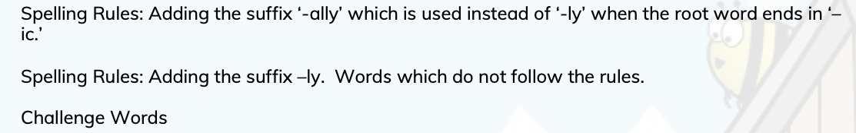 | Poetry  To use similes, metaphors, personification.  To discuss meanings of words and phrases that create humour, and sound effects in poetry (nonsense poems, tongue twisters, riddles).  To collect suitable words and phrases in order to write poems and short descriptions;  To write poetry that uses sound to create effects (e.g. onomatopoeia, alliteration, distinctive rhythms).  To choose and prepare poems for performance choosing appropriate expression, tone, volume and use of voices and other sounds.  To rehearse and improve performance.  To write new and extended verses for performances based on models of ‘performance’ and oral poetry, e.g. rhythms, rhymes.  To locate use of similes.  To identify different patterns of rhyme and verse in poetry, e.g. choruses, rhyming couplets, alternate line rhymes.  To understand the following terms and identify them in poems (verse, chorus, couplet, stanza, rhythm, rhyme, alliteration).
Week 4-7 | Punctuation  Use the possessive apostrophe and apostrophes for contractions.  To know how to use double inverted commas and the following speech.
Week 4-7 | Sentence construction  To write for purposes.  To use paragraphs to organize ideas.  Write from memory sentenced dictated from the teacher.  To identify and use prepositions.  To understand what a main clause is.  To understand and use subordinate clauses.  Use verb tenses consistently.

Summer 1
 | Grammar, punctuation | Spelling | Genre skills | Handwriting
Week 1-3 | Spelling  To spell 55% of the Year 3/4 CEW. | Week 1-3  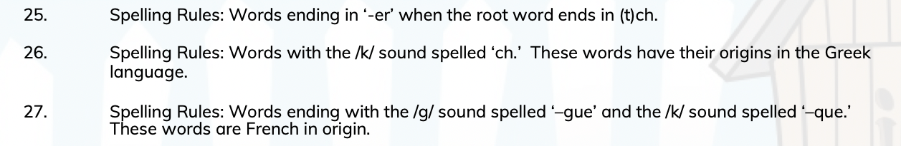 | Explanation  After carrying out a practical activity, (e.g.) experiment, investigation, construction task) contribute to creating a flowchart or cyclical diagram to explain the process as member of group with the teacher.  After seeing and hearing an oral explanation of the process, explain the same process orally also using flowchart, language and gestures appropriately.  Read, with help, flowcharts or cyclical diagrams explaining other processes and then read others independently.  Following other practical tasks, produce a simple flowchart or cyclical diagram independently.  Create an explanation using technical, subject-specific vocabulary and write in a knowledgeful, formal tone. | Focus on fluidity at speed.
Week 1-3 | Punctuation  Use the possessive apostrophe and apostrophes for contractions.  To know how to use double inverted commas and the following speech. |  | Fact file  Pose and orally rehearse questions ahead of writing and record these in writing, before reading.  Recognise that non-fiction books on similar themes can give different information and present similar information in different ways.  Use contents pages and alphabetically ordered texts (e.g.) dictionaries, encyclopaedias, indexes, directories, registers.  Locate definitions/ explanations in dictionaries and glossaries.  Write simple information texts incorporating labelled pictures and diagrams, charts, lists as appropriate.  Draw on knowledge and experience of texts in deciding and planning what and how to write.  Use organisational techniques such as sub headings, bullet points, paragraphing.
Week 1-3 | Sentence construction  To write for purposes.  To use paragraphs to organize ideas.  Write from memory sentenced dictated from the teacher.  To identify and use prepositions.  To understand what a main clause is.  To understand and use subordinate clauses.  To distinguish between a consonant and vowel.  To understand and use some cohesive devices (adverbials, conjunctions, pronouns, synonyms) across a text and paragraph.  Use verb tenses consistently.
Week 4-7 | Spelling  To spell 55% of the Year 3/4 CEW. | 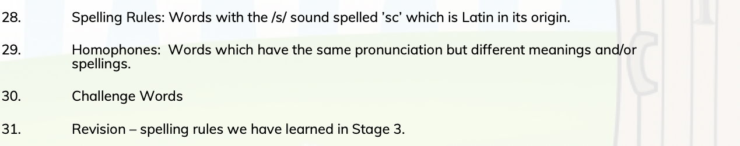 | Poetry  To use similes, metaphors, personification.  To discuss meanings of words and phrases that create humour, and sound effects in poetry (nonsense poems, tongue twisters, riddles).  To collect suitable words and phrases in order to write poems and short descriptions;  To invent calligrams and a range of shape poems, selecting appropriate words and careful presentation.  To write poetry that uses sound to create effects (e.g. onomatopoeia, alliteration, distinctive rhythms).  To choose and prepare poems for performance choosing appropriate expression, tone, volume and use of voices and other sounds.  To rehearse and improve performance.  To write new and extended verses for performances based on models of ‘performance’ and oral poetry, e.g. rhythms, rhymes.  To write poems based on personal or imagined experience, linked to poems read.  To understand the use of figurative language in poetry and prose; compare poetic phrasing with narrative/descriptive examples.  To locate use of similes.  To identify different patterns of rhyme and verse in poetry, e.g. choruses, rhyming couplets, alternate line rhymes.  To understand the following terms and identify them in poems (verse, chorus, couplet, stanza, rhythm, rhyme, alliteration).
Week 4-7 | Punctuation  Use the possessive apostrophe and apostrophes for contractions.  To know how to use double inverted commas and the following speech. |  | Newspaper recount  After a practical activity or undertaking some research in books or the web, take part in a discussion in another curriculum subject, generalising from repeated occurrences or observations.  Distinguish between a description of a single member of a group and the group in general e.g. a particular dog and dogs in general. Read texts containing information in a simple report format, e.g. There are two sorts of x...; They live in x...; the As have x..., but the B’s etc.  To use simple devices for structure. Eg sub heading  Assemble information on another subject and use the text as a template for writing a report on it, using appropriate language to present and categorise ideas.  Write simple first person recounts linked to topics of interest/study or to personal experience, using the language of texts read as models for own writing.  Maintain a consistency in tense and in 3rd person.
Week 4-7 | Sentence construction  To write for purposes.  To use paragraphs to organize ideas.  Write from memory sentenced dictated from the teacher.  To identify and use prepositions.  To understand what a main clause is.  To understand and use subordinate clauses.  To distinguish between a consonant and vowel.  To understand and use cohesive devices (adverbials, conjunctions, pronouns, synonyms) across a text and paragraph.  Use verb tenses consistently.

Summer 2
 | Grammar, punctuation | Spelling | Genre skills | Handwriting
Week 1-3 | Spelling  To spell 60% of the Year 3/4 CEW.  To understand compound words.  To add the prefixes il-, im- in  add -ation to form a noun | Week 1-3  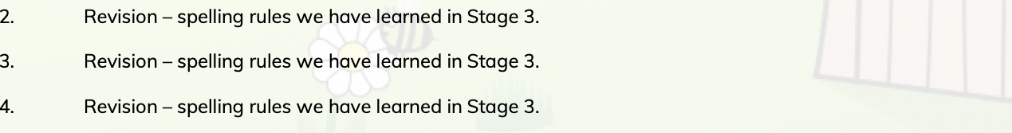 | Narrative  Describe settings and characters.  Write complete stories with a full sequence of events in narrative order Including a dilemma or conflict and resolution.  Write an opening paragraph and further paragraphs for each stage of the story.  Use either first or third person consistently.  Use conventions for written dialogue use dialogue to create atmosphere...  Consolidate understanding of sequential story structure: identify common, formal elements in story openings and endings and typical features of particular types of story.  Notice common themes, similar key incidents and typical phrases or expressions.  Note the use of language to set scenes, build tension, create suspense.  Notice the difference between first and third person accounts; Identify examples of a character telling the story in the first person;  make deductions about characters feelings, behaviour and relationships based on descriptions and their actions in the story.  Settings are used to create atmosphere.  Look at examples of scene changes that move the plot on, relieve or build up the tension.
Week 1-3 | Punctuation  Use the possessive apostrophe and apostrophes for contractions.  To know how to use double inverted commas and the following speech.
Week 1-3 | Sentence construction  To write for purposes.  To use paragraphs to organize ideas.  Write from memory sentenced dictated from the teacher.  To identify and use prepositions.  To understand what a main clause is.  To understand and use subordinate clauses.  To distinguish between a consonant and vowel.  To understand and use cohesive devices (adverbials, conjunctions, pronouns, synonyms) across a text and paragraph.  Use verb tenses consistently.
Week 4-7 | Spelling  To spell 60% of the Year 3/4 CEW.  To use the first three letters of a word to locate it in a dictionary.  To spell common homophones correctly.
Week 4-7 | Punctuation  Use the possessive apostrophe and apostrophes for contractions.  To know how to use double inverted commas and the following speech.
Week 4-7 | Sentence construction  To write for purposes.  To use paragraphs to organize ideas.  Write from memory sentenced dictated from the teacher.  To identify and use prepositions.  To understand what a main clause is.  To understand and use subordinate clauses.  To distinguish between a consonant and vowel.  To understand and use cohesive devices (adverbials, conjunctions, pronouns, synonyms) across a text and paragraph.  Use verb tenses consistently.

