
Southfields Primary School Progression
Year 2

Autumn 1
 | Grammar, punctuation | Spelling | Genre skills | Handwriting
Week 1-3 | Spelling  To segment spoken words into phonemes and representing these by graphemes, spelling some correctly.  Learning new ways of spelling phonemes for which one or more spellings are already known, and learn some words with each spelling.  Spell 75% of the Year 1 CEW | 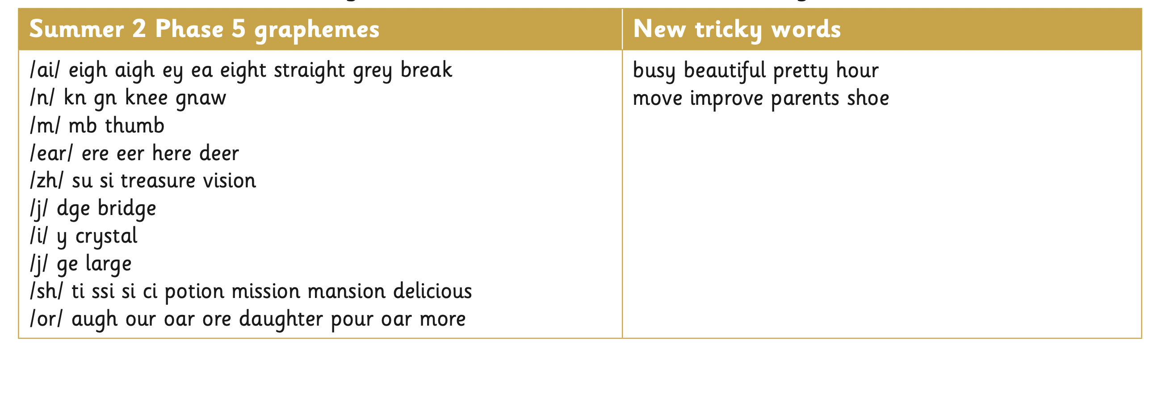 | Re-tell familiar stories using narrative structure and dialogue from the text; include relevant details and sustain the listener’s interest; tell own real and imagined stories; explore characters’ feelings and situations using improvisation; dramatise parts of own or familiar stories and perform to class or group.  Imitate familiar stories by borrowing and adapting structures; write complete stories with a sustained, logical sequence of events.  Include setting; create characters, e.g. by adapting ideas about typical story characters. | To form lower case letters in relative size to one another.  Write capital letters and digits of the correct size, orientation and relationship to one another and to lower case letters.  Use spacing between words that reflect the size of the letters.
Week 1-3 | Punctuation  To use capital letters and full stops 50% of the time accurately.  To use ? and ! within some sentences.
Week 1-3 | Sentence construction  To use past tense on occasions  To use simplistic adjectives to describe.
Week 4-7 | Spelling  To segment spoken words into phonemes and representing these by graphemes, spelling some correctly.  Learning new ways of spelling phonemes for which one or more spellings are already known, and learn some words with each spelling,  Spell 10 of the Year 2 CEW  Spell the contracted words can’t and don’t |  | Letters  Understand and use the layout of a letter correctly.  Understand the purpose of the letter they are writing.  Understand who will be reading the letter and if the tone should be formal or informal.  Punctuate sentences using full stops and capital letters.  Use a variation of punctuation learnt such as question marks and exclamation marks.
Week 4-7 | Punctuation  To use capital letters and full stops 75% of the time accurately.  To use ? and ! within some sentences.  To use capital letters for the pronoun I.
Week 4-7 | Sentence construction  To use past tense consistently  To understand and use noun phrases correctly.

Autumn 2
 | Grammar, punctuation | Spelling | Genre skills | Handwriting
Week 1-3 | Spelling  To segment spoken words into phonemes and representing these by graphemes, spelling some correctly.  Learning new ways of spelling phonemes for which one or more spellings are already known, and learn some words with each spelling, including a few common homophones eg. There and their  Spell 20 of the Year 2 CEW  Spell the contracted words can’t, won’t, didn’t and don’t | 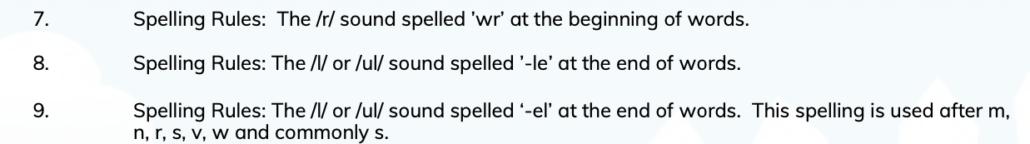 | Recount  Describe incidents from own experience in an audible voice using sequencing words and phrases such as ‘then’, ‘after that’;  listen to other’s recounts and ask relevant questions.  Read personal recounts and begin to recognise generic structure, e.g. ordered sequence of events, use of words like first, next, after, when.  Write simple first person recounts linked to topics of interest/study or to personal experience, using the language of texts read as models for own writing, maintaining a consistent in tense | To form lower case letters in relative size to one another.  Write capital letters and digits of the correct size, orientation and relationship to one another and to lower case letters.  Use spacing between words that reflect the size of the letters.
Week 1-3 | Punctuation  To use capital letters and full stops of the time accurately.  To use ? and ! within some sentences.  To use capital letters for the pronoun I and proper nouns.  To use commas to separate items in a list.  To use the possessive apostrophe
Week 1-3 | Sentence construction  To use past and present tense consistently  To understand and use noun phrases correctly.
Week 4-7 | Spelling  To segment spoken words into phonemes and representing these by graphemes, spelling some correctly.  Learning new ways of spelling phonemes for which one or more spellings are already known, and learn some words with each spelling, including a few common homophones eg. There and their  Spell 20 of the Year 2 CEW  Spell the contracted words can’t, won’t, didn’t and don’t | 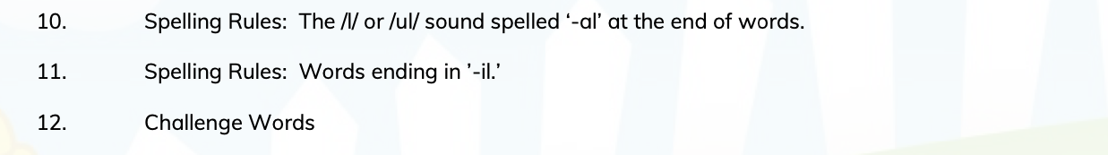
Week 4-7 | Punctuation  To use capital letters and full stops of the time accurately.  To use ? and ! within some sentences.  To use ? and ! within some sentences.  To use capital letters for the pronoun I and proper nouns.  To use commas to separate items in a list.  To use the possessive apostrophe
Week 4-7 | Sentence construction  To use past and present tense consistently  To understand and use noun phrases correctly.  To know and use prefixes and suffixes

Spring 1
 | Grammar, punctuation | Spelling | Genre skills | Handwriting
Week 1-3 | Spelling  To segment spoken words into phonemes and representing these by graphemes, spelling most correctly.  Learning new ways of spelling phonemes for which one or more spellings are already known, and learn some words with each spelling, including a few common homophones eg. There they’re, and their, you’re your  Spell 30 of the Year 2 CEW  Spell the contracted words can’t, won’t, didn’t, I’ll and don’t  Spell plurals using the possessive apostrophe | 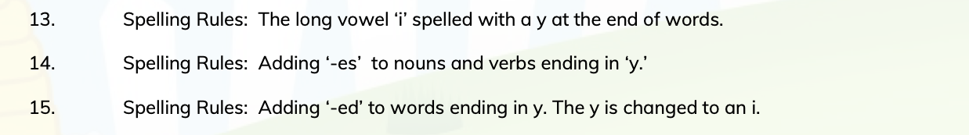  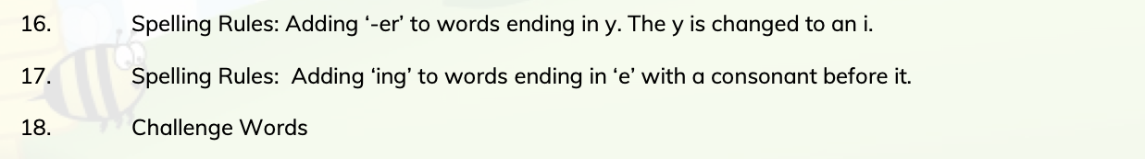 | .  Re-tell familiar stories using narrative structure and dialogue from the text; include relevant details and sustain the listener’s interest; tell own real and imagined stories; explore characters’ feelings and situations using improvisation; dramatise parts of own or familiar stories and perform to class or group.  Imitate familiar stories by borrowing and adapting structures; write complete stories with a sustained, logical sequence of events.  Use past tense and 3rd person consistently.  Include setting; create characters, e.g. by adapting ideas about typical story characters. | To form lower case letters in relative size to one another.  Write capital letters and digits of the correct size, orientation and relationship to one another and to lower case letters.  Use spacing between words that reflect the size of the letters.
Week 1-3 | Punctuation  To use capital letters and full stops accurately.  To use ? and ! within some sentences.  To use ? and ! within some sentences.  To use capital letters for the pronoun I and proper nouns.  To use commas to separate items in a list.  To use the possessive apostrophe
Week 1-3 | Sentence construction  To use past and present tense consistently and progressive tense ( he was drumming)  To understand and use noun phrases correctly.  To know and use prefixes and suffixes
Week 4-7 | Spelling  To segment spoken words into phonemes and representing these by graphemes, spelling most correctly.  Learning new ways of spelling phonemes for which one or more spellings are already known, and learn some words with each spelling, including a few common homophones eg. There they’re, and their, you’re your, to two,  Spell 30 of the Year 2 CEW  Spell the contracted words can’t, won’t, didn’t, I’ll and don’t  Spell plurals using the possessive apostrophe |  | Letters  Understand and use the layout of a letter correctly.  Understand the purpose of the letter they are writing.  Understand who will be reading the letter.  Punctuate sentences using full stops and capital letters.  Use a variation of punctuation learnt such as question marks and exclamation marks. | To form lower case letters in relative size to one another.  Write capital letters and digits of the correct size, orientation and relationship to one another and to lower case letters.  Use spacing between words that reflect the size of the letters.
Week 4-7 | Punctuation  To use capital letters and full stops of the time accurately.  To use ? and ! within some sentences.  To use capital letters for the pronoun I and proper nouns.  To use commas to separate items in a list.  To use the possessive apostrophe |  | Report  Pose and orally rehearse questions ahead of writing and record these in writing, before reading.  Recognise that non-fiction books on similar themes can give different information and present similar information in different ways.  Write simple information texts incorporating labelled pictures and diagrams, charts, lists as appropriate.  Draw on knowledge and experience of texts in deciding and planning what and how to write.  Maintain consistency in non- narrative, including purpose and tense.  Use key words or phrases, subheadings)  .  Close read text to gain information, finding the meaning of unknown words by deducing from text, asking someone, or referring to a dictionary or encyclopaedia.  Make simple notes from non-fiction texts, e.g. key words and phrases, page references, headings, to use in subsequent writing.
Week 4-7 | Sentence construction  To use past and present tense consistently and progressive tense ( he was drumming)  To understand and use noun phrases correctly.  To know and use prefixes and suffixes  To choose vocabulary for purpose. |  | Instructions  Listen to and follow a single more detailed instruction and a longer series of instructions.  Think out and give clear single oral instructions.  Contribute to class composition of instructions with teacher scribing.  Write a set of consecutive instructions independently.
Week 4-7 |  |  | Explanations  Read captions, pictures and diagrams on wall displays and in simple books that explain a process.  Draw pictures to  illustrate a process and use the picture to explain the process orally.  To use technical language to explain a process.

Spring 2
 | Grammar, punctuation | Spelling | Genre skills | Handwriting
Week 1-3 | Spelling  To segment spoken words into phonemes and representing these by graphemes, spelling most correctly.  Learning new ways of spelling phonemes for which one or more spellings are already known, and learn some words with each spelling, including a few common homophones eg. There they’re, and their, you’re your, to too two, witch which,  Spell 40 of the Year 2 CEW  Spell the contracted words can’t, won’t, didn’t, I’ll and don’t  Hasn’t, she’ll, he’ll, we’ll  Spell plurals using the possessive apostrophe  To distinguish between homophones and near homophones. | 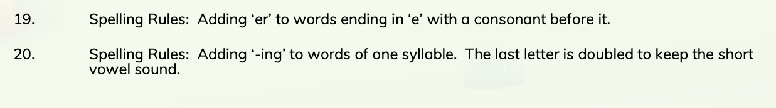  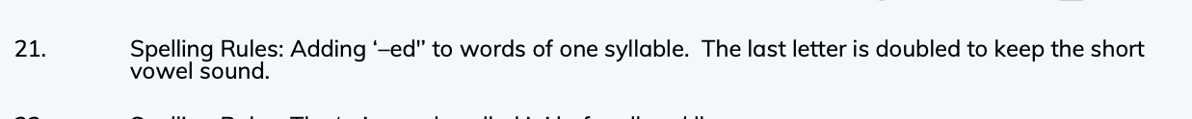  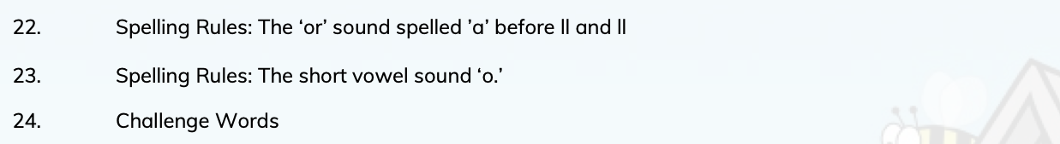 | Narratives  Re-tell familiar stories using narrative structure and dialogue from the text; include relevant details and sustain the listener’s interest; tell own real and imagined stories; explore characters’ feelings and situations using improvisation; dramatise parts of own or familiar stories and perform to class or group.  Imitate familiar stories by borrowing and adapting structures; write complete stories with a sustained, logical sequence of events.  Use past tense and 3rd person consistently.  Include setting; create characters, e.g. by adapting ideas about typical story characters. | To form lower case letters in relative size to one another.  Start using some of the diagonal and horizontal strokes needed to join letters and understand which letters, when adjacent to one another, are better unjoined.  Write capital letters and digits of the correct size, orientation and relationship to one another and to lower case letters.  Use spacing between words that reflect the size of the letters.
Week 1-3 | Punctuation  To use capital letters and full stops accurately.  To use ? and ! within some sentences.  To use capital letters for the pronoun I and proper nouns.  To use commas to separate items in a list.  To use the possessive apostrophe
Week 1-3 | Sentence construction  To use past and present tense consistently and progressive tense ( he was drumming)  To understand and use noun phrases correctly.  To know and use prefixes and suffixes.  To choose vocabulary for purpose.  To be able to edit punctuation and spelling.
Week 4-7 | Spelling  To segment spoken words into phonemes and representing these by graphemes, spelling most correctly.  Learning new ways of spelling phonemes for which one or more spellings are already known, and learn some words with each spelling, including a few common homophones eg. There they’re, and their, you’re your, to too two, witch which,  Spell 40 of the Year 2 CEW  Spell plurals using the possessive apostrophe.  To distinguish between homophones and near homophones.
Week 4-7 | Punctuation  To use capital letters and full stops accurately.  To use ? and ! within some sentences.  To use capital letters for the pronoun I and proper nouns.  To use commas to separate items in a list.  To use the possessive apostrophe
Week 4-7 | Sentence construction  To use past and present tense consistently and progressive tense ( he was drumming)  To understand and use noun phrases correctly.  To know and use prefixes and suffixes.  To choose vocabulary for purpose.  To be able to edit punctuation and spelling.

Summer 1
 | Grammar, punctuation | Spelling | Genre skills | Handwriting
Week 1-3 | Spelling  To segment spoken words into phonemes and representing these by graphemes, spelling most correctly.  Learning new ways of spelling phonemes for which one or more spellings are already known, and learn some words with each spelling, including a few common homophones eg. There they’re, and their, you’re your, to too two, witch which,  Knew, new  Spell 50 of the Year 2 CEW | Week 1-3  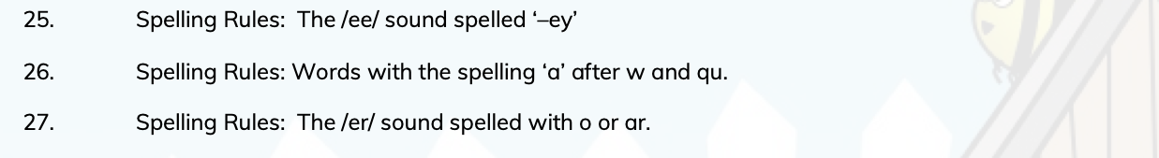  Week 4-7  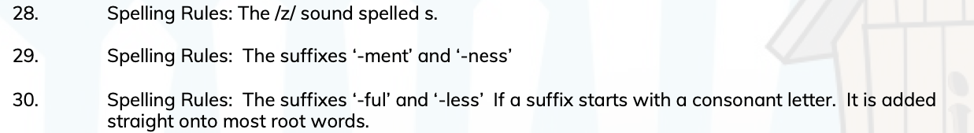 | Re-tell familiar stories using narrative structure and dialogue from the text; include relevant details and sustain the listener’s interest; tell own real and imagined stories; explore characters’ feelings and situations using improvisation; dramatise parts of own or familiar stories and perform to class or group.  Imitate familiar stories by borrowing and adapting structures; write complete stories with a sustained, logical sequence of events.  Use past tense and 3rd person consistently.  Include setting; create characters, e.g. by adapting ideas about typical story characters.  Include some dialogue.  Use phrases drawn from story language to add interest, (e.g.) she couldn’t believe her eyes. | To form lower case letters in relative size to one another.  Start using some of the diagonal and horizontal strokes needed to join letters and understand which letters, when adjacent to one another, are better unjoined.  Write capital letters and digits of the correct size, orientation and relationship to one another and to lower case letters.  Use spacing between words that reflect the size of the letters.
Week 1-3 | Punctuation  To use full stops and capital letters correctly in most sentences.  To use ? and ! within some sentences.  To use capital letters for the pronoun I and proper nouns.  To use commas to separate items in a list.  To use the possessive apostrophe |  | Recount  Describe incidents from own experience in an audible voice using sequencing words and phrases such as ‘then’, ‘after that’;  listen to other’s recounts and ask relevant questions.  Read personal recounts and begin to recognise generic structure, e.g. ordered sequence of events, use of words like first, next, after, when.  Write simple first person recounts linked to topics of interest/study or to personal experience, using the language of texts read as models for own writing, maintaining consistency in tense and person.  Letters  Understand and use the layout of a letter correctly.  Understand the purpose of the letter they are writing.  Understand who will be reading the letter and if the tone should be formal or informal.  To begin to paragraph my letter.  Punctuate sentences using full stops and capital letters.  Use a variation of punctuation learnt such as question marks and exclamation marks.  Persuasion  Through games and role play begin to explore what it means to persuade or be persuaded, and what different methods might be effective.
Week 1-3 | Sentence construction  To use past and present tense consistently and progressive tense ( he was drumming)  To understand and use noun phrases correctly.  To know and use prefixes and suffixes  To choose vocabulary for purpose.  To be able to edit punctuation and spelling.
Week 4-7 | Spelling  To segment spoken words into phonemes and representing these by graphemes, spelling most correctly.  Learning new ways of spelling phonemes for which one or more spellings are already known, and learn some words with each spelling, including a few common homophones eg. There they’re, and their, you’re your, to too two, witch which,  Knew, new, whole, hole  Spell 50 of the Year 2 CEW
Week 4-7 | Punctuation  To use full stops and capital letters correctly in most sentences.  To use ? and ! within some sentences.  To use capital letters for the pronoun I and proper nouns.  To use commas to separate items in a list.  To use the possessive apostrophe  To be able to edit punctuation and spelling.
Week 4-7 | Sentence construction  To use past and present tense consistently and progressive tense ( he was drumming)  To understand and use noun phrases correctly.  To choose vocabulary for purpose.

Summer 2
 | Grammar, punctuation | Spelling | Genre skills | Handwriting
Week 1-3 | Spelling  To segment spoken words into phonemes and representing these by graphemes, spelling most correctly.  To segment spoken words into phonemes and representing these by graphemes, spelling most correctly.  Learning new ways of spelling phonemes for which one or more spellings are already known, and learn some words with each spelling, including a few common homophones eg. There they’re, and their, you’re your, to too two, witch which,  Knew, new, whole, hole  Spell 60 of the Year 2 CEW | Week 1-3  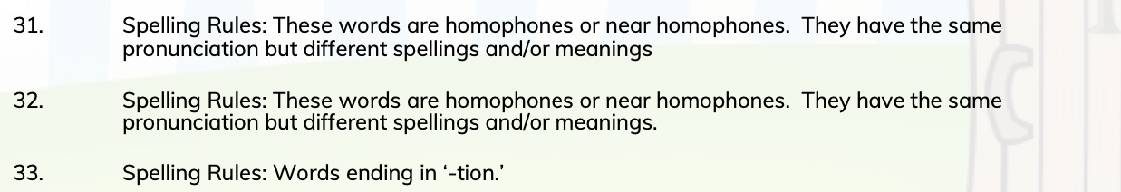  Week 4-7  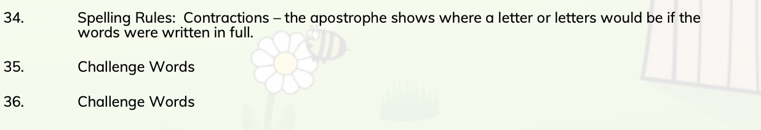 | Re-tell familiar stories using narrative structure and dialogue from the text; include relevant details and sustain the listener’s interest; tell own real and imagined stories; explore characters’ feelings and situations using improvisation; dramatise parts of own or familiar stories and perform to class or group.  Imitate familiar stories by borrowing and adapting structures; write complete stories with a sustained, logical sequence of events.  Use past tense and 3rd person consistently.  Include setting; create characters, e.g. by adapting ideas about typical story characters.  Include some dialogue.  Use phrases drawn from story language to add interest, (e.g.) she couldn’t believe her eyes.
Week 1-3 | Punctuation  To use full stops and capital letters correctly in most sentences.  To use ? and ! within some sentences.  To use capital letters for the pronoun I and proper nouns.  To use commas to separate items in a list.  To use the possessive apostrophe | Letters  Understand and use the layout of a letter correctly.  Understand the purpose of the letter they are writing.  Understand who will be reading the letter and if the tone should be formal or informal.  To begin to paragraph my letter.  Punctuate sentences using full stops and capital letters.  Use a variation of punctuation learnt such as question marks and exclamation marks. | Recount  Describe incidents from own experience in an audible voice using sequencing words and phrases such as ‘then’, ‘after that’;  listen to other’s recounts and ask relevant questions.  Read personal recounts and begin to recognise generic structure, e.g. ordered sequence of events, use of words like first, next, after, when.  Write simple first person recounts linked to topics of interest/study or to personal experience, using the language of texts read as models for own writing, maintaining consistency in tense and person.
Week 1-3 | Sentence construction  To use past and present tense consistently and progressive tense ( he was drumming)  To know and use prefixes and suffixes |  | Letters  Understand and use the layout of a letter correctly.  Understand the purpose of the letter they are writing.  Understand who will be reading the letter and if the tone should be formal or informal.  To begin to paragraph my letter.  Punctuate sentences using full stops and capital letters.  Use a variation of punctuation learnt such as question marks and exclamation marks.  Persuasion  Through games and role play begin to explore what it means to persuade or be persuaded, and what different methods might be effective.
Week 4-7 | Spelling  To segment spoken words into phonemes and representing these by graphemes, spelling most correctly.  To segment spoken words into phonemes and representing these by graphemes, spelling most correctly.  Learning new ways of spelling phonemes for which one or more spellings are already known, and learn some words with each spelling, including a few common homophones eg. There they’re, and their, you’re your, to too two, witch which,  Knew, new, whole, hole, one won,  Spell 70 of the Year 2 CEW
Week 4-7 | Punctuation  To use full stops and capital letters correctly in most sentences.  To use ? and ! within some sentences.  To use commas to separate items in a list.  To use the possessive apostrophe
Week 4-7 | Sentence construction  To use past and present tense consistently and progressive tense ( he was drumming)

