Language Support for Secondary School Students
Our secondary school language support box focuses on two key areas of language development that continue throughout secondary school learning: Vocabulary and Narrative
Vocabulary
Secondary students need to acquire a large amount of vocabulary during the course of their studies. Some of this will be subject-specific e.g. ‘gravitational potential energy’ but a lot of it is more general and will apply across many subjects e.g. ‘explain’, ‘evaluate’, ‘consider’.
Students with a limited range of words at their disposal will struggle to express their ideas orally and in writing and will benefit from support with developing their vocabulary skills.

Narrative
Narrative or storytelling is an important feature of our lives and goes beyond novels to include the ways in which we interact with others to tell, explain and share our experiences and are a means through which we interpret and understand the world around us.
Storytelling is a complex skill which draws on many different areas of language competence such as vocabulary, grammar, abstract thinking and general life experiences.
To listen to, or understand, stories we also draw on a range of non-linguistic skills such as understanding of time and cause and effect, understanding of other people and typical social interactions, understanding of feelings and behaviours as well as drawing on our general understanding and experiences of the world.

In this Box:
The Vocabulary Enrichment Intervention Programme Victoria L Joffe
The Narrative Intervention Programme Victoria L Joffe

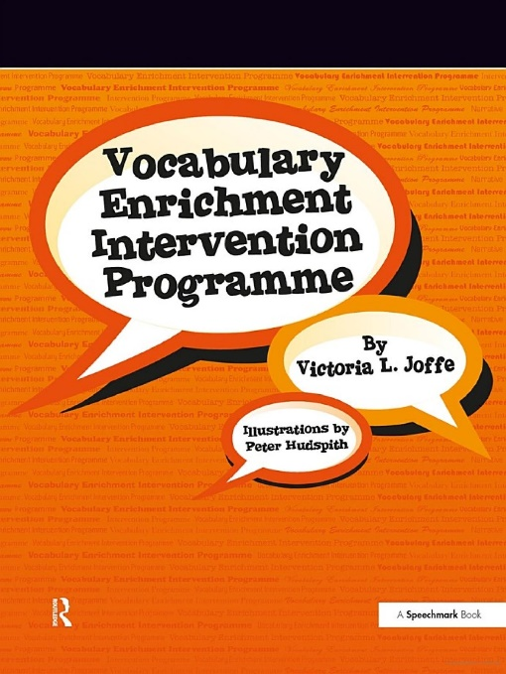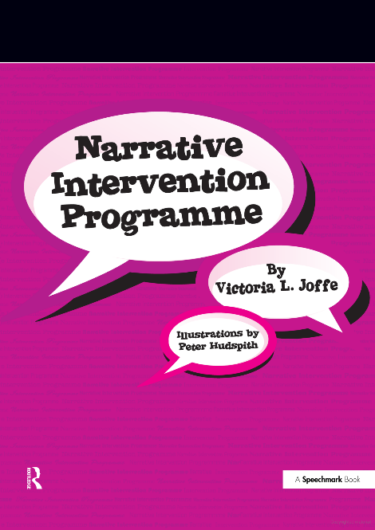

The Vocabulary Enrichment Intervention Programme
This comprehensive vocabulary development programme is designed to be used with secondary school students.
The programme:
- increases awareness of the importance of vocabulary at school and at home
- uses the concept of a word map to help students to explore the range of connections between words
- introduces the idea of word classes, prefixes and suffixes, synonyms and antonyms and discusses the origins of words
- uses themes that are likely to be familiar from students’ class subjects such as organisms, healthy living, the human body and space
- explores the use of figurative and idiomatic language as well as double meanings
- introduces the idea of a word detective to help students problem-solve independently with new vocabulary they come across
This is a multi-session programme designed to be delivered by a teaching assistant, teacher of specialist teacher with a small group of students
Each session comes with a full session plan, materials and teaching notes for delivery.

The Narrative Intervention Programme
This comprehensive programme is designed to be used for secondary school students.
The programme aims to:
- Introduce the concept of narratives (or stories) and discuss different types of narratives.
- Introduce the structure of narratives using a story planner (beginning, middle, end)
- Explore characterization
- Set mood through setting, time and place
- Discuss ways of making stories more exciting through plot, themes, climax and resolutions
- Discuss different ways of ending a story by providing a moral or using a cliffhanger
- Understand the sequential nature of storytelling
- Identify and use literary devices such as rhyme, rhythm, alliteration, double meanings, hyperbole
- Differentiate prose and poetry
- Practising listening to and telling stories, reading and writing
- Evaluating stores
- Enhance appreciation of the wonder of storytelling
- Create an awareness of how storytelling can be used to enhance learning in school, social interactions and home environments
- Identify ways of using the story planner to structure homework and essays in lessons and exams
There are 21 separate intervention sessions which can be delivered by a teaching assistant, teacher or specialist teacher.
Each session comes with a full session plan, materials and teaching notes for delivery.

