Vocabulary Development Box
Many children struggle with learning words, knowing words and calling words to mind when they want to say them.
These resources will help you work with children who need support in building the range of words that they feel confident in using.
Included in this box:
Word Aware Stephen Parsons & Anna Branagan
Semantic Links Sadie Bigland & Jane Speake
Find the Link ColorCards Games

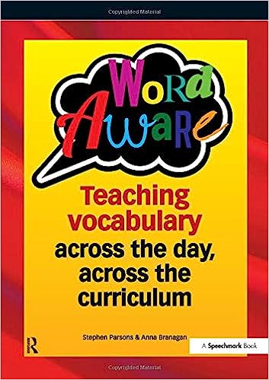
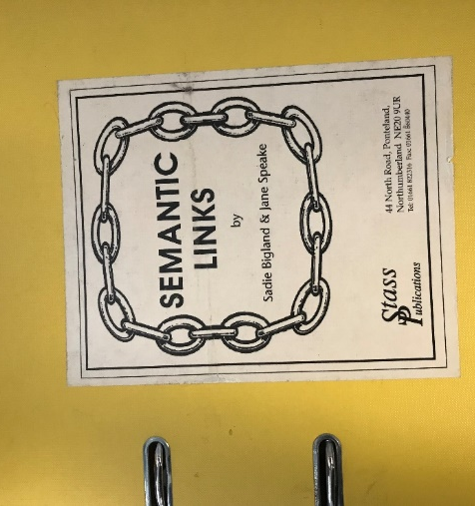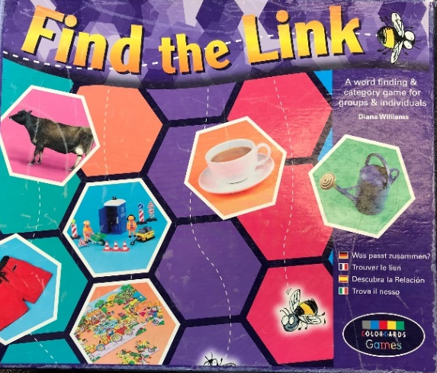

Word Aware

This is a comprehensive guide to teaching vocabulary and the approach can be adapted for whole class work, small group work or work with individual children.
Word Aware is suitable for use with children in both KS1 and KS2.
It takes you through some key principles in vocabulary development and comes with a wealth of practical ideas and tips for incorporating these principles into general and targeted teaching.
Particular areas covered include:
- Specific teaching of targeted vocabulary
- Topic vocabulary
- Concepts
- Vocabulary in Literacy
- Vocabulary of Emotions
It also explains the concept of a ‘word detective’ to encourage children to develop their independent word-learning skills and gives ideas for working with small groups and for working in collaboration with parents.

Semantic Links
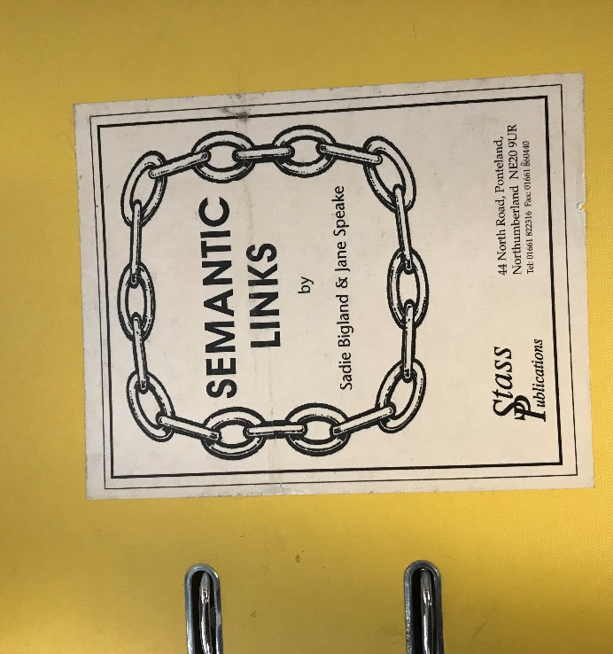
This is a series of worksheets designed for work with children who struggle to make connections between words and ideas.
For each worksheet, there is a central word (e.g. car) surrounded by varying numbers of related and unrelated words (e.g. bus, plane, trousers, cat). The child should decide for each central word which of the surrounding words are related.
At a basic level, children may point or name their responses. At a more advanced level, they can begin to explain why their chosen item goes with the central item. They could also explain why an unrelated item does not go with the central item.
This can also be used to prompt further discussion and word generation e.g. if ‘car’ goes with ‘bus’, what else could go with ‘car’ and ‘bus’?

Find the Link
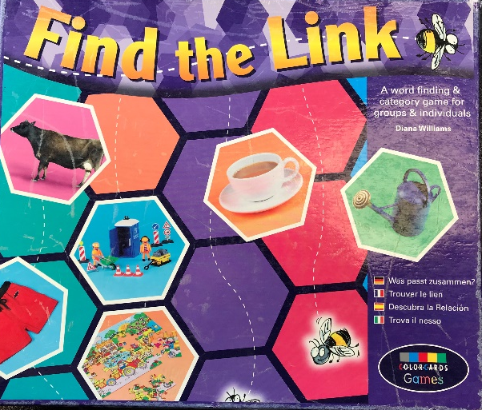
This is a board game designed to help children to find and explain the links between words and ideas and to develop categorization skills.
Categories include:
Animals; clothes; transport; food
Functions of objects e.g. reading, playing, drinking, cooking
Places of objects e.g. handbag, first aid box, garden, bathroom, kitchen
You can use the game in multiple ways – choose a category and the players have to collect other items from that category. Alternatively, players can choose two cards and decide if and how they are linked – this can then lead to further discussions.

