Concepts Box
Children with weak language skills often have difficulty in learning to use words to describe basic concepts.
‘Concepts’ covers a range of different words used to talk about ideas such as:
Number: e.g. enough, more, how many, few, most
Size: e.g. large, small, wide, narrow, deep
Time: e.g. first, next, then, before, after, later
Shape: e.g. square, flat, circle
Position: e.g. along, between, underneath, top
Colour: e.g. blue, red, dark
General characteristics: e.g. hard, smooth, dry, loud
This set of resources will help you in supporting children who are developing their use and understanding of these concept words.
In this box:
Developing Language Concepts Bridget Burrows
PORIC Concepts Glinette Woods & Deborah Acors
Achieving Speech and Language Targets Catherine Delamain & Jill Spring
Talk about Mathematics LDA Cards
Time and Growth LDA Cards
Adjectives LDA Cards
Photo Prepositions LDA Cards
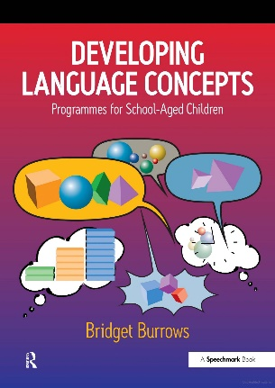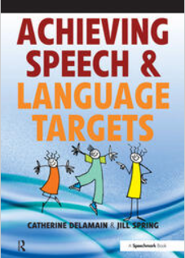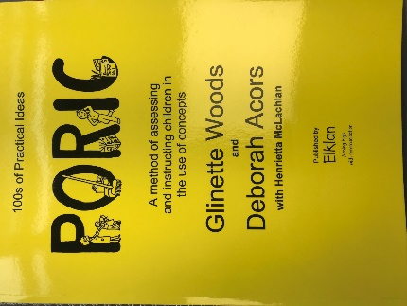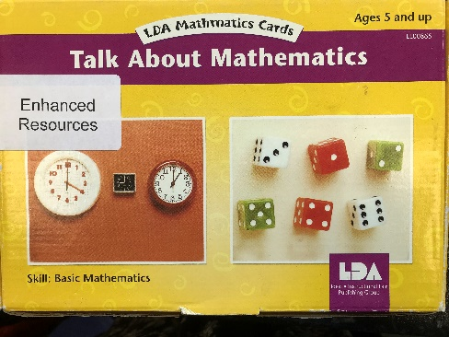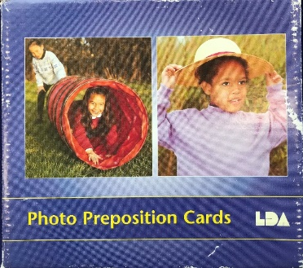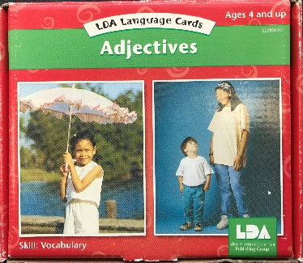

Developing Language Concepts
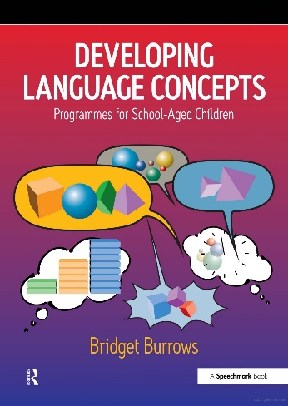
This is a comprehensive programme of activities for developing children’s use and understanding of a range of basic concepts.
The activities are carefully structured from early to later developing concepts so that you can target your activities at the appropriate level.
The activities at each level cover a range of different concept types such as:
Amount e.g. all, some, a few
General characteristics e.g. clean, hard , loud, different, rough, dark
Place e.g. in, on, through, top, near
Time e.g. again, later, now, already
The programme also covers words for space, shape and size.

Achieving Speech & Language Targets
This is a book of games and activities which is ideal for small groups of children who need support with their speech and language skills. Most of the activities can also be adapted to carry out with individual children.
It has been designed with Reception and Year One children in mind.
You can use it for activities which focus on aspects of understanding, talking and speech sounds. Each skill area is presented in a developmental sequence moving from so that you can judge the right difficulty level for your group of children. Many basic concepts are covered in the ‘Understanding Language’ activities
Understanding Language
Skills such as:
Naming words Action words Describing words Position Words Colours
Questions Quantity Words Time words Stories
Using Language
Skills such as:
Naming words Action words Asking questions Using Grammar
Talking in Sentences
Developing Speech Sounds
Skills such as:
Discrimination Activities
Making sounds
Practising sounds

Photo Preposition Cards
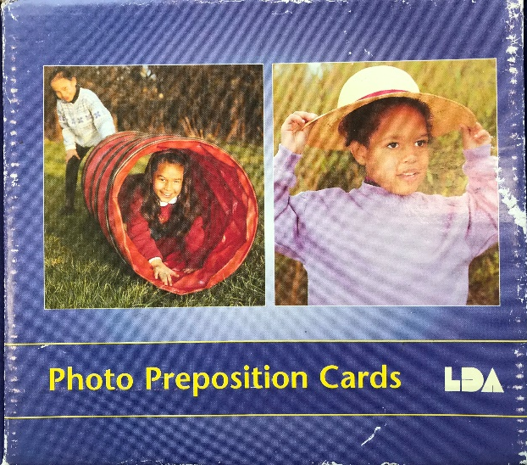
A series of colour photo cards illustrating different prepositions such as:
‘behind’, ‘down’, ‘around’, ‘in front of’
Use them to:
Model using: Talk about the pictures with the children and about what the children in the photos are doing
Practise understanding: ‘Find a photo showing ‘in’’
Practise describing: ‘Where is the boy in this picture?’ – ‘he’s in the tunnel’
Find lots of pictures of the same preposition with different verbs to talk about: ‘she’s kicking the ball between the boys’, ‘he’s standing between the children’
Adjectives Cards
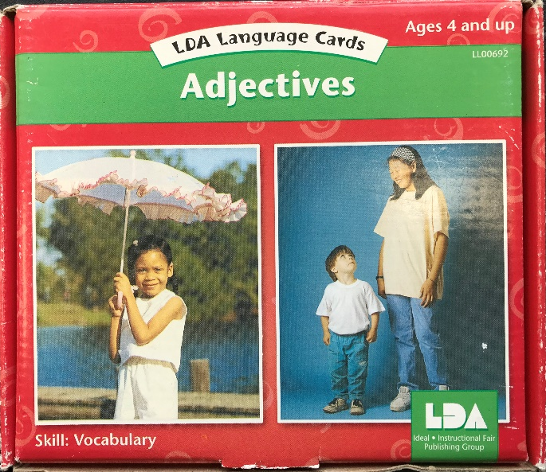
A set of colour cards illustrating a range of general characteristics used for descriptions, such as:
Tall, fast, new, open, big, soft, light
Use them to:
Model using the words: Talk about the pictures with the children and what they can see in the picture. Expand your discussion by relating the words to their own experiences beyond the pictures – what else is hot?
Practise understanding: ‘Find a picture that shows ‘dirty’’
Practise describing: ‘Tell me about this boy’s jumper’ – ‘It’s very big’
Expand to the real world: ‘What else in this room is ‘hard’?

Talk About Mathematics
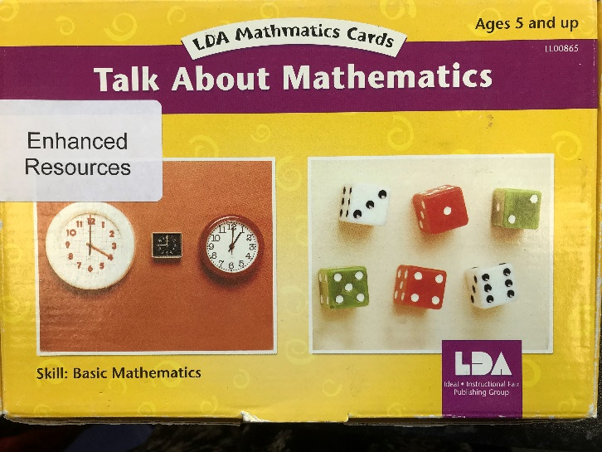
A series of photo cards which illustrate many of the common concepts which occur in early mathematics, such as:
As many as, everything, equal, each, more
They also cover a range of other concepts such as:
prepositions (next to, between etc), general characteristics (long, narrow, slow etc )
Each card has key language terms that you can use listed on the back together with some useful discussion points to talk about. There are also some suggested follow-up activities to help you consolidate children’s understanding.

PORIC
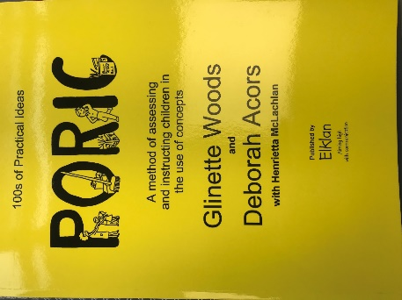
This is a comprehensive assessment and development programme for teaching basic concepts.
‘PORIC’ refers to the system they have adopted for the teaching of concepts:
Personal
Objects
Representational
Independence
Consolidation
Concepts are organized into a developmental sequence and cover categories such as:
Quality e.g. like
Colour e.g. blue, red
Texture e.g. rough, soft
Sound e.g. noisy
Shape e.g. flat, round
Size e.g. long, small
Movement e.g. quickly
Quantity e.g. many, another
Space e.g. in front of, outside
Time e.g. soon, today
Number e.g. first, next
Personal Qualities e.g. hungry, nice, silly
There are plenty of activity ideas together with pictures and assessment forms

