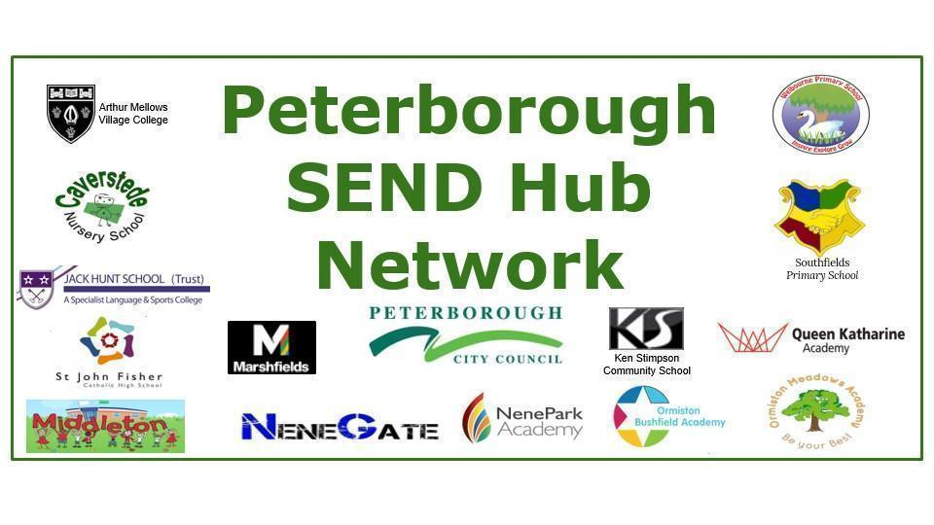
SEND HUB ACTION PLAN 2022-23

Centre of Expertise in SLCN Hub at Southfields Primary School
This action plan outlines how this designated centre of expertise/hub will work with Peterborough Local Authority to :
- Build capacity within their own setting to meet the needs of children and young people with special educational needs or disabilities (SEND), with particular focus on their designated area of expertise
- Build knowledge, expertise and resilience in Peterborough Schools and Early Years or FE settings to meet the needs of children and young people who have a special educational need or disability (SEND)
- Support the principles and aims of the Peterborough and Cambridgeshire SEND Strategy 2019-24 which aims to ensure that SEND is Everybody’s Business and is embedded into the work of all practitioners..Please see below a link to the SEND Strategy on the Local Offer; https://fis.peterborough.gov.uk/kb5/peterborough/directory/site.page?id=HHHfPER04x4
This Action Plan will be reviewed at least termly.

Action Plan 2022-23
Clear line - Centre of Expertise for SLCN
Southfields Primary School

Southfields Primary Annual Plan No.4 – 2022/23
Intention | Implementation | Impact | RAG rated | Completion date
1: To ensure that Southfields maintains high expectations and knowledge in its area of expertise (SLCN).  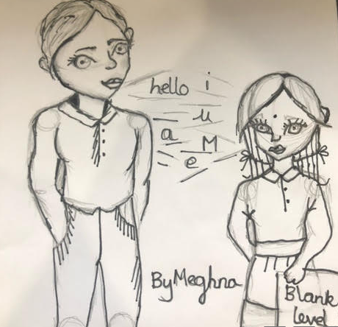 | Annual training/ specific induction of new staff (ECTs too)
 | EKLAN training for TAs (L2 or L3) and teachers (L3). This will be a rolling programme, both online and face to face.
 | ELKLAN accreditation renewal process (2023)
 | Termly monitoring (environment, teaching and SEND provision, APDR), upskilling to enable staff to articulate the school vision and aims for SLCN.
 | 1:1 support and coaching/ team teaching where appropriate to ensure high quality lessons that embed best practise for SLCN.
 | Unclear Speech training for appropriate staff.
 | ELKLAN 0-5 training for appropriate staff (such as EYFS, KS1 and high needs SEND).
 | Arrange specific SLCN training such as PECs, Z-vibe oral motor training and Makaton for staff who require it.
 | Oracy 22-23 to further enhance Voice 21 Oracy across the school.
 | Hub Manager to enhance their knowledge and understanding of the role by keeping up to date with local and national trends in SLCN.
 | Being part of a national project in DLD from Cambridgeshire University.
 | Parent Newsletter (½ termly and finding trends/working with them)
 | To organise a well –resourced SLCN/Hub room within the school to promote the Hub further.
 | To interview, appoint and induct a new speech and language therapist.
To ensure the provision of SLCN for pupils at Southfields remains embedded and is of high quality. | To further support and provide training for staff to enhance their understand and deliver SLCN programs.
 | Termly monitoring (environment, teaching and SEND provision, APDR), including from a child’s perspective.
 | Revision, updating and promotion/ training of Hub resources.
 | To assess and monitor the NELI outcomes in order to ensure effective provision and progression.
To ensure that the awareness and identification of SLCN across Southfields, in all Year Groups is increased and the profile of SLCN is raised. | Training/ induction of new staff to ensure they are well equipped to identify need.
 | Termly monitoring (environment, teaching and SEND provision, ADPR) to ensure that pupils are identified in a timely manner.
 | Termly assessments and updating of children with SLCN - teachers to be informed of outcomes, recommendations and resources in order to be confident in providing the correct support for SLCN.
To ensure that the awareness and identification of SLCN across the city, in all settings is increased and the profile of SLCN is raised. | Termly training to focus on the needs of the city with a particular focus on secondary settings and 0-5 years).
 | Directly focus on schools with the highest reported numbers of SLCN - see SEND data from census Jan ‘22
 | Collaboration with NHS collaboratively (ECT training)
 | Collaboration with Health Visitors to increase their own knowledge and understanding of identification and support for SLCN, particularly to support parents.
 | Collaboration with Caverstede (EYFS Hub)
 | Collaboration directly with Senior Leadership Team including Headteachers.
To make a direct impact across the city on:  - Knowledge and confidence of supporting SLCN in settings,  - Pupil outcomes | Revisit schools the Hub has supported for evidence of impact, for examples through using: Staff voice, pupil voice, progress data.
To raise the profile of Southfields Hub across the city | Attend SEND forums
To raise the profile of Southfields Hub across the city | Share information in SEND Newsletters
To raise the profile of Southfields Hub across the city | Update and share website regularly at training and forum events
To support parents at Southfields in raising awareness/ how to support children with SLCN | SLCN coffee mornings, Newsletters, Class Dojo communications, website content and videos.
 | Accessible training resources - videos, websites, leaflets
 | Parental Newsletters shared with Southfields staff.
To raise awareness of SLCN and development of communication in young children amongst parents/ primary caregivers across the city | Working with Health Visitors/ Early Years Team/ Toddler groups
 | Collect measurable impact

